26th January 2017,

THE CHAIRMAN
ANUM EBI ASSOCIATION
LONDON

Dear Sir / Madam,
APPRECIATION LETTER
On behalf of the Management, Expenditure board and entire staff of the Salvation Army health Centre at Anum. I am once again writing to express our gratitude for your kind gesture to donate Money as a support to the above mentioned health facility in the aid of continuing its Maternity and Administrative building.
The donation have made it possible for us to complete Two (2) rooms designated as offices for the Administrator and Accountant for the Health facility. The officers are ready to move and work in this new offices. Your contributions have help the health facility to achieve this completion phase of the building project and we are most grateful for your significant contribution and support.
We pray that God will reward you abundantly for whatever you have contributed towards this project both individually and as a group. When the project is completed, it would enable the facility to continue providing efficient and effective health care services to its catchment area and the general public as whole.
We count on your usual support to this health Centre.
Find attached the state of the building.
Thank you
God bless you
Yours Sincerely

Daniel Addo
(Assistant Administrator)

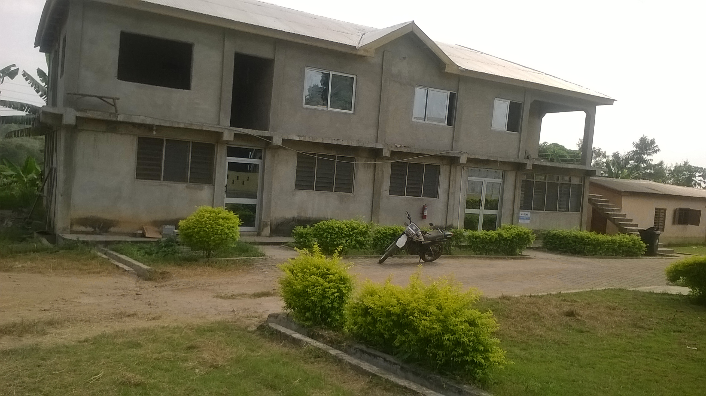
The whole building (Current stage) The whole building (Current stage)
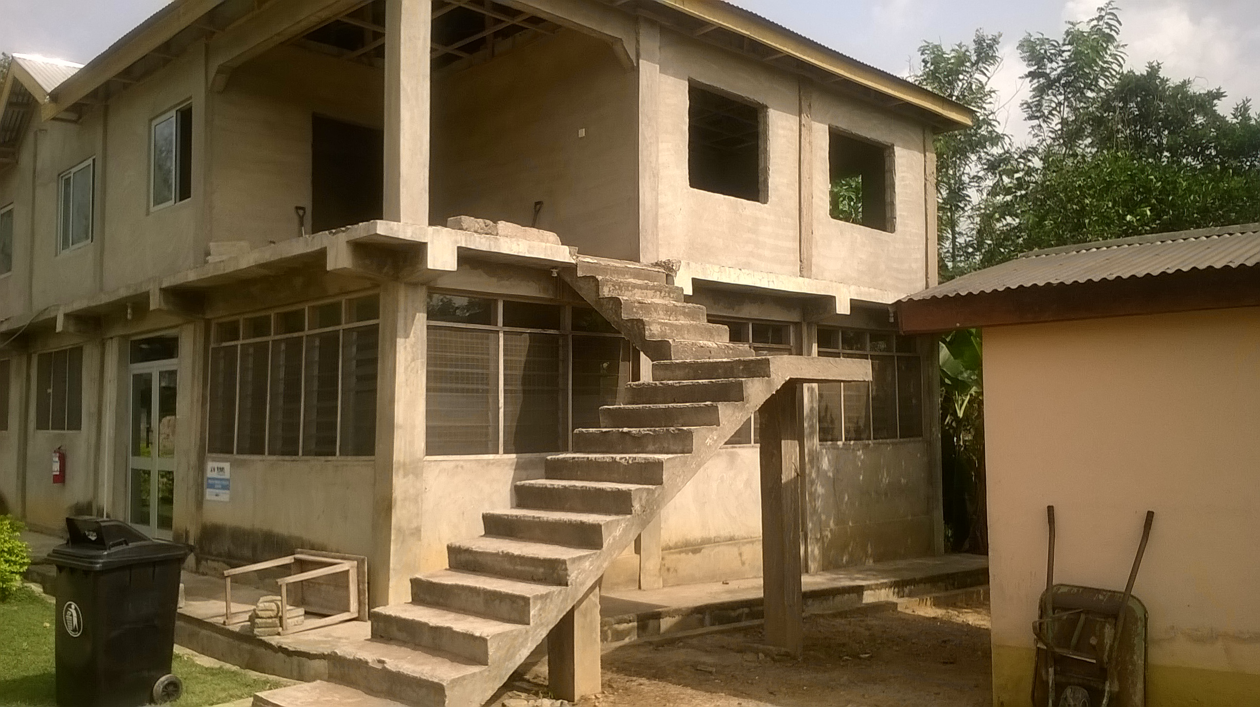

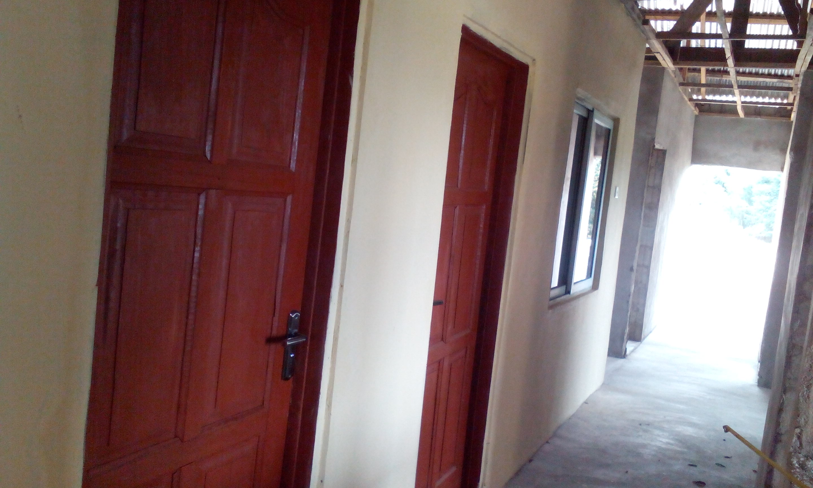

The two (2) completed offices This is the ceiling for the two (2) completed offices

Inside of the Accountant office
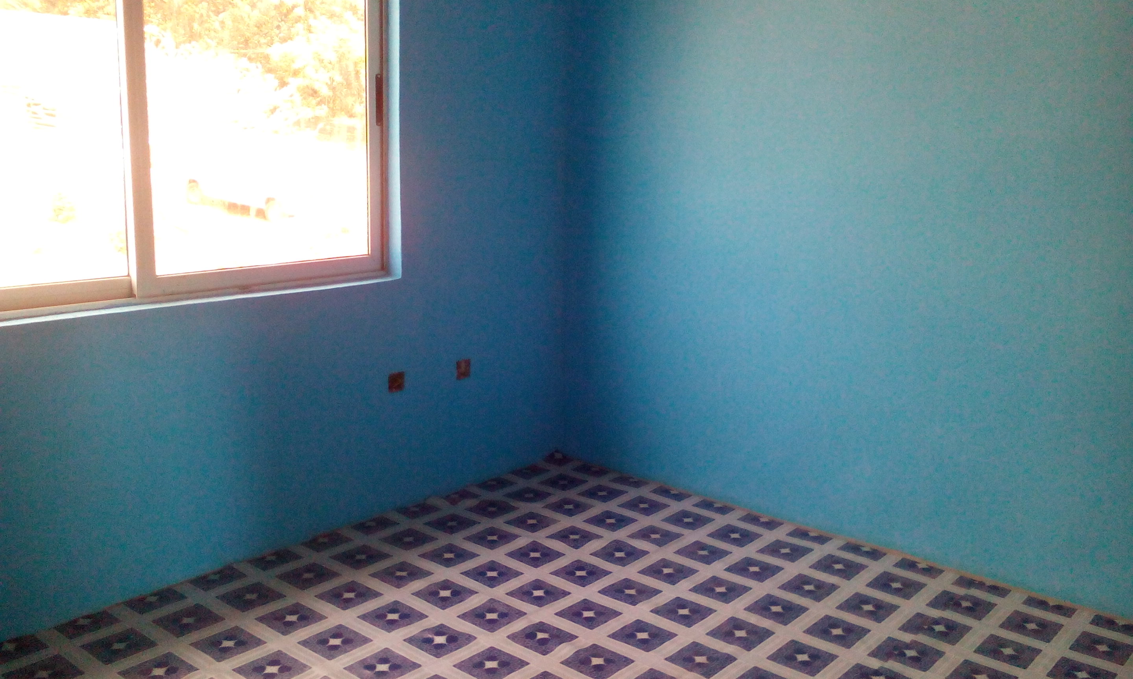
Inside of Administrators office
