**TABLE OF CONTENT PAGES**

1. Brief history on the Salvation Army MSCS in Ghana…………………………......2

2. International mission statement……………………………………………………5

3. Territorial Mission Statement- Ghana …………………………………………….5

4. Medical, Social & Community Services Mission Statement ……………………...5

5. Leadership and governance…………………………………………………...........6

6. Health service delivery…………………………………………………………......7

7. Human resources……………………………………………………………….....20

8. Health financing .…………………………………..………..…..………………. 22

9. Health Information ……………………………………………..………………...26

10. Health Technology …………………………………………………..……........ 28

11. Community participation and ownership………………………………………..31

12. Partnership Development …………………………………………………….....33

13. Visitors ………………………………………………………………………….34

14. Staff Delivery and Funeral………………………………………………………36

15. Conclusion………………………………………………………………………37

16. Appendix 1 Patient Chart ……………………………………………………… 39

17. Appendix 2 Budget – Medical Social and Community Service Department …..42

1. **BRIEF HISTORY OF THE SALVATION ARMY MEDICAL, SOCIAL AND COMMUNITY SERVICES IN GHANA**

The Salvation Army in Ghana was established in 1922 with establishment of schools and churches. In 1950, The Salvation Army started Medical and Social work with the establishment of rural clinics. Currently Ghana through the Medical, Social and Community Services Department (**MSCSD)** has nine (9) clinics and Two (2) Rehabilitation Centre’s and Two Vocational Training Centre’s.

**(1.1) BRIEF HISTORY OF ANUM HEALTH CENTRE**

Anum Health Centre was opened in 1961. In response to a great need, it started as Baby’s Home where motherless babies were cared for until they were two (2) years old and could return to their families. In addition to that, an outpatient’s clinic was held twice weekly.

With changing needs in the community, the health Centre program also changed. The babies were transferred to **Ajumako-Ba in the Central Region**. The Orphanage was not progressing and the then **Sister Martine** in-charge thought it wise to move elsewhere.

After the transferred of the baby’s home, the facility commenced 24 hours providing health service in general Out Patient Department (OPD), In-Patient, Maternity and Outreach services etc, to all people who needs our service regardless ethnic group and their nationality back ground within the surrounding and outside the communities.

**(1.2) The Health Centre and It External Environment**

The Health is situated at a place called Anum in the Asuogyaman District of Eastern Region of Ghana. Total population of the District is 108,783. It is about one hundred and forty (140) kilometers from Accra. Anum Salvation Army Health Centre is under the Anum / Boso Sub District an area of about Fifteen (15) communities with disparate socio-economic condition and an estimate current population of Twenty–Two Thousand Eight Hundred And Forty–Five (22, 845).

**(1.3) Catchment Area of the Health Centre**

The Health Centre used to render outreach service in Three (3) surrounding communities within the catchment area of the facility but currently or under year review, the Ghana health service (GHS) have taken over Two (2) communities from the facility leaving only One (1) community namely Asikuma. In addition the facility have divided Anum community into Two (2) areas where outreach services are being provide.

Inhabitants within the catchment area are made up with different tribes with Ewe being dominated over the population.

The Ethnic Groups Percentage is Shown Below

Ewe - 50%

Guan - 30%

Akan - 15%

Krobo /Adangbe - 5%

**(1.4) Inhabitant Occupation and Sources of Income**

Types of occupation and sources of income are basically Farming and petty trading (small scale). Greater numbers of people are unemployed only few are employed under white color jobs and receiving small salaries.

Even though there is no active market in Anum but there are two (2) markets Centre’s outside the community. These markets are found in Dzemani in the Volta Region and Labolabo in the Eastern Region.

The Volta Lake is the main sources of domestic water use; however, there are also a few streams in the community.

**(1.5) Education**

There are Three (3) primary Three (3) Junior Secondary, one (1) Senior Secondary School and one (1) Vocational Schools. The illiteracy level among the population is moderate**.**

**(1.6) Transportation**

The Health Centre under year review used one vehicle with registered number **GN 8932 13** for travelling purposes**.** The Vehicle is use for Administrator’s travelling and administration purposes. The same vehicle is also being used as ambulance when there is a referred case to a hospital and also for all the Outreach programs;

Vehicle for the facility (GN 8932 -13)

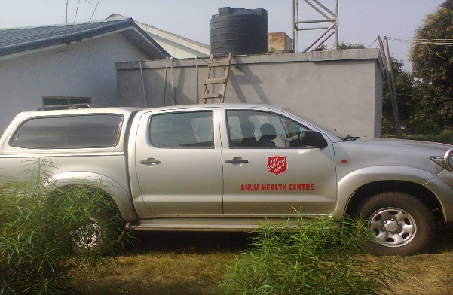   
  
**(1.7) The Health Centre Administration**

The administration is made up of Administrator, Assistant Administrator, Accountant, Biostatistics Assistant, Driver, two security men and two labourers.

**(1.8) Building Project**

Currently the Salvation Army Health Centre - Anum is having two on-going building projects one is **Maternity and Administration block** and the other one is **Operation Theater**.

**(1.8.1) The Stage of the Buildings**

The maternity / Administration block is a story Building of which about Ninety – Seven 97% of the ground flood for maternity is completed and about Sixty - Five (65%) of the second floor for Administration is also completed while the theater is still at the foundation level. The figures below show the current state or stages of the two (2) building project of the Health Centre.

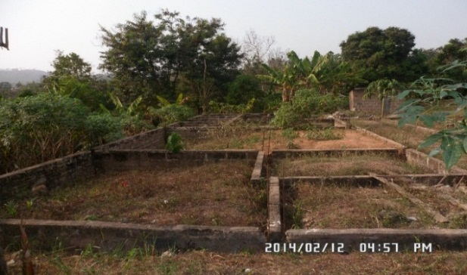Maternity and Administration block The Theater is still on foundation Level 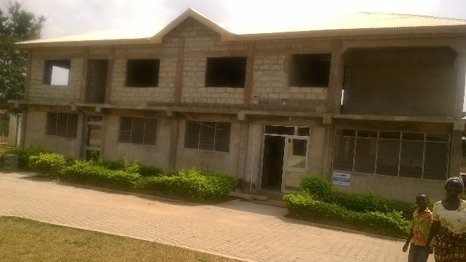

**(2). INTERNATIONAL MISSION STATEMENT**

The Salvation Army has an international mission statement that sets the identity and direction for every command and Centre that the Army operates.

The international mission statement of The Salvation Army state that, "The Salvation Army, an international movement, is an evangelical part of the universal Christian Church. Its message is based on the Bible. Its ministry is motivated by love of God. Its mission is to preach the gospel of Jesus Christ and meet human needs in His name without discrimination."

**TERRITORIAL MISSION STATEMENT- GHANA**

Our mission is to seek ways to introduce people to the Gospel of Jesus Christ.

Our teaching must strengthen them in their faith and understanding of the one true God, facilitating the development and growth of the Christian church.

Our outreach is aimed at seeking and meeting the needs of the local community with initiative and vision, as servants of Christ.

**(3).MEDICAL, SOCIAL & COMMUNITY SERVICES MISSION STATEMENT**

We of the Salvation Army medical and social service department, “are motivated by God’s love, and aimed to demonstrate the practical healing ministry of Jesus Christ.

We aim to provide services and programs to alleviate human suffering and enhance healing and restoration of body, mind and spirit, for the individual and the community.

We are committed to providing quality health care and identifying the medical and social needs of whosoever. By supplying basic human needs, personal, moral, and through physical rehabilitation, we are committed to all person who come within the sphere of our influence, regardless of race, color, creed age or sex.

We aim to facilitate access to health care for the general population and to provide affordable, quality health care to all our clients. In everything we want to show Christ to all who come to our Centre’s through the love, care and service we provide”

**(4.) LEADERSHIP AND GOVERNANCE**

Anum Health Centre is now one of such centers administrated by The Salvation Army Ghana Territory. The overall management is from the Salvation Army International Headquarters in London.

The next level of The Salvation Army leadership and governance is the Territory which The Territory is headed by the Territorial Commander who reports directly to IHQ in all matters concerning the Territory.

The Territorial Commander is assisted by a Chief Secretary and other departmental Secretaries who are responsible for overseeing the operation of The Salvation Army's activities throughout the Territory.

The next level is the Director for Medical, Social and Community Services who co-ordinate at the territorial level in health and social work in the territory.

The Salvation Army Health facilities / Centre’s in Ghana are members of Christian Health Association of Ghana (CHAG) who co-ordinate with the government at national level.

Another level is the district director for health who monitors the operations of the Centre through monthly, quarterly and annual report and visitation team from the district office.

The facility also did self-assessment to cover the following areas under the year review

A **Regulatory and Compliance**

1. **Validation of registrations**: Data for registration or renewal of all required certificates compiled. However CHAG Certificate have been received.
2. **Audited Financial Report**: There is no external auditor made available in the health facility. However an auditor comes from Salvation Head Quarters annually to audit the facility books of account.
3. **MOH/CHAG Memorandum of Understanding**: There is no copies of MOU is available in the health facility :

**B Strategic Management**

**Use of strategic plan:** There is a strategic plan available covering the year under review but all Management Team members and ward and departmental Heads are not copies of the strategic plan.

**C Management Capacity**

**Preparation Annual Plan and Budget:** The final draft of the annual plan and budget is submitted to the approving authority of the health facility.

**(5) HEALTH SERVICE DELIVERY**

**5.1 Health Service Delivery programs**

The facility health Programs aims to produce rigorous and relevant Services to improve the quality, accessibility and organization of health services. The programs carried out for the year under review are as follows:

* Outpatient
* In-patient clinic
* Outreach Clinic
* Child Welfare Clinic
* Ante-natal Care
* Delivery
* Post-natal
* Family Planning Clinic
* HIV/AIDS Counseling
* Circumcision
* Lab Investigation
* Community Based Health Volunteers Campaign.

**(5.2) Health Problems**

The major health problems in the area are still communicable and environmental related diseases. Malaria is still dominating as the first position among the top ten (10) diseases, and follows by Respiratory Tract Infection. As compare to the previous years. There were also very high level of other reported cases like Skin Diseases & Ulcers, Joint Pains and etc. The total figure for diseases reported under year review is **26,858**, the top ten cases amounted to **15,172** and other reported diseases amounted to **11,686**.

|  |  |  |  |  |
| --- | --- | --- | --- | --- |
| **REPORT READING ON THE TOP TEN (10) DISEASES FOR THE YEAR 2015** | | | | |
|  | DISEASES | **2015** | **2014** | **2013** |
| 1 | Malaria | 6,108 | 6,186 | 6,933 |
| 2 | Respiratory Tract Infection | 4,228 | 3,829 | 3,628 |
| 3 | Rheumatic & Joint Pains | 2,878 | 3,065 | 2,904 |
| 4 | Skin Diseases & Ulcers | 418 | 602 | 219 |
| 5 | Diarrhoea Diseases | 414 | 1,010 | 261 |
| 6 | Otitis Media | 270 | 325 | 105 |
| 7 | Aneamia | 238 | 724 | 383 |
| 8 | Urinary Tract Infection | 218 | 243 | 326 |
| 9 | Intestinal Worm | 203 | 650 | 136 |
| 10 | Home Injury | 197 | 257 | 89 |
|  | All Others | 11,686 | 12,879 | 9,152 |
|  | **Total** | **26,858** | **29,770** | **24,136** |

**5.3 Out-Patients Department (OPD)**

The year under review, outpatients department (OPD) was run from Monday to Sunday, 24 hours daily. The night nurse, Medical Assistant and midwife see emergency cases at night. Diagnosis is made on the clinical signs and symptoms and Lab Investigation results. The OPD also includes daily dressing and injections, follow-up treatments and fourteen bedded retention rooms.

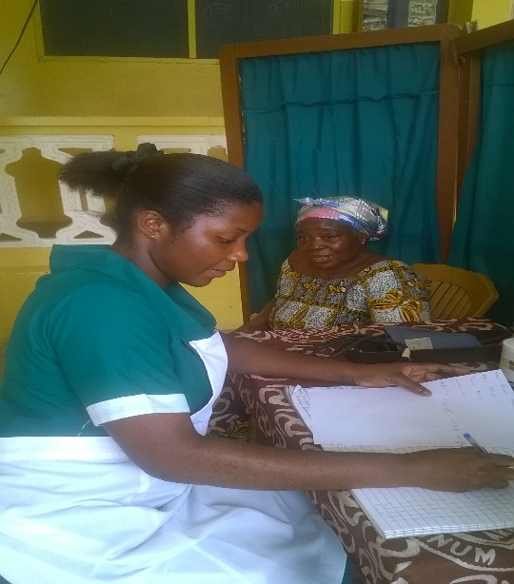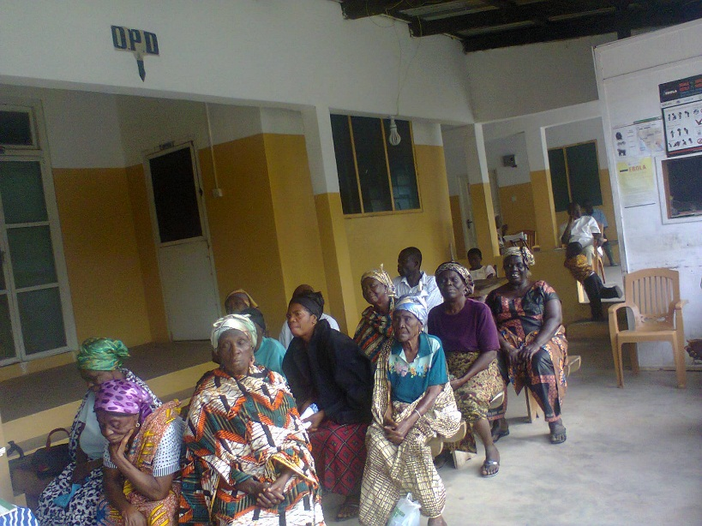The nurse attending to a patient and other Patient waiting to be seen at OPD

|  |  |  |  |  |  |  |  |  |  |  |
| --- | --- | --- | --- | --- | --- | --- | --- | --- | --- | --- |
| **STATEMENT OF OUT-PATIENT DEPATMENT** | | | | | | | | | | |
| **GHANA HEALTH SERVICE** | | | | | | | | | | |
| **INSTITUTION …*SALVATION ARMY HEALTH CENTRE - ANUM* …REGION……*EASTERN*** | | | | | | | | | | |
| **DISTRICT: *ASUOGYAMAN*  MONTH: JANUARY - DECEMBER YEAR: 2015** | | | | | | | | | | |
|  | **INSURED PATIENTS** | | | | **NON-INSURED PATIENTS** | | | | **TOATL** | |
|  | **NEW** | | **OLD** | | **NEW** | | **OLD** | |  |  |
| **AGE GROUP** | **MALE** | **FEMALE** | **MALE** | **FEMALE** | **MALE** | **FEMALE** | **MALE** | **FEMALE** | **MALE** | **FEMALE** |
| **<28 Days** | 30 | 14 | 27 | 12 | 9 | 4 | 2 | 9 | **68** | **39** |
| **<1 YEARS** | 97 | 65 | 119 | 52 | 70 | 30 | 60 | 34 | **346** | **181** |
| **1-4 YEARS** | 137 | 165 | 450 | 423 | 71 | 52 | 95 | 84 | **753** | **724** |
| **5-9 YEARS** | 165 | 224 | 348 | 338 | 54 | 62 | 101 | 67 | **668** | **691** |
| **10-14 YEARS** | 129 | 125 | 240 | 241 | 46 | 40 | 33 | 50 | **448** | **456** |
| **15-17YEARS** | 138 | 238 | 165 | 273 | 62 | 67 | 24 | 65 | **389** | **643** |
| **18-19 YEARS** | 174 | 191 | 199 | 174 | 65 | 56 | 48 | 46 | **486** | **467** |
| **20-34 YEARS** | 154 | 335 | 269 | 522 | 83 | 124 | 95 | 156 | **601** | **1137** |
| **35-49 YEARS** | 99 | 200 | 228 | 450 | 66 | 54 | 47 | 107 | **440** | **811** |
| **50-59 YEARS** | 129 | 234 | 210 | 416 | 34 | 49 | 24 | 65 | **397** | **764** |
| **60-69 YEARS** | 172 | 244 | 229 | 507 | 37 | 21 | 43 | 41 | **481** | **813** |
| **>70YEARS** | 243 | 381 | 457 | 1206 | 41 | 45 | 42 | 104 | **783** | **1736** |
| **TOTAL ALLGE** | **1667** | **2416** | **2941** | **4614** | **638** | **604** | **614** | **828** | **5860** | **8462** |
| **GRAND TOTAL** | **4083** | | **7555** | | **1242** | | **1442** | | **14322** | |

|  |  |
| --- | --- |
| TOTAL NEW ATTENDANCE | 5325 |
| TOTAL OLD ATTENDANCE | 8997 |
| TOTAL ATTENDANCE | 14322 |

|  |  |
| --- | --- |
| TOTAL ATTENDANCE INSURED | 11,638 |
| TOTAL ATTENDANCE NON INSURED | 2,684 |
| TOTAL ATTENDANCE | 14,322 |

|  |  |
| --- | --- |
| No of patients with malaria below 5 years | 725 |
| No of patients malaria above 5 years | 4,364 |

**5.4 Maternity Department**

The maternity department has ten (10) beds and provides 24hour services for labour cases and Ante-natal patients requiring treatment. The women are admitted for two to three days, post-delivery and longer, where necessary. Pre-term and sick babies are admitted when appropriate..

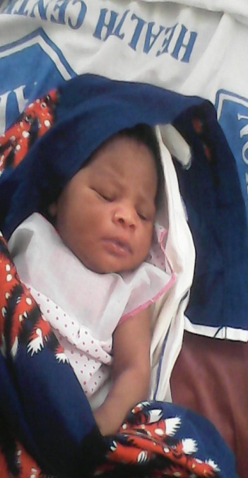

One of the new born babies within the year 2015

Below is the table and graph for the figures

|  |  |  |  |
| --- | --- | --- | --- |
| **DELIVERY REPORT FOR THE YEAR 2015** | | |  |
| **YEARS** | **2015** |  | **2014** |
| Total Delivery | **183** |  | 181 |
| Male | **97** |  | **90** |
| Female | **86** |  | **77** |
| Weight <2.5kg | **26** |  | **9** |

|  |
| --- |
|  |
|  |

**ABOUNDED A DAY OLD BABY**

During the year under review the Ghana police service brought a day old baby whom they found by the road side at Asikuma to the facility for safe keeping and care. In their report state that somebody abounded the Child over there.

Investigation was carried out by the Ghana Police Service and the facility, The mother and family of the baby was found but the mother refuse to accept the back as her child, therefore the family and the police officers agreed the that child should be take care at Anum Health Centre.

Per this agreement the child is being taking care by the Administrator at Health Centre.

Abounded Baby

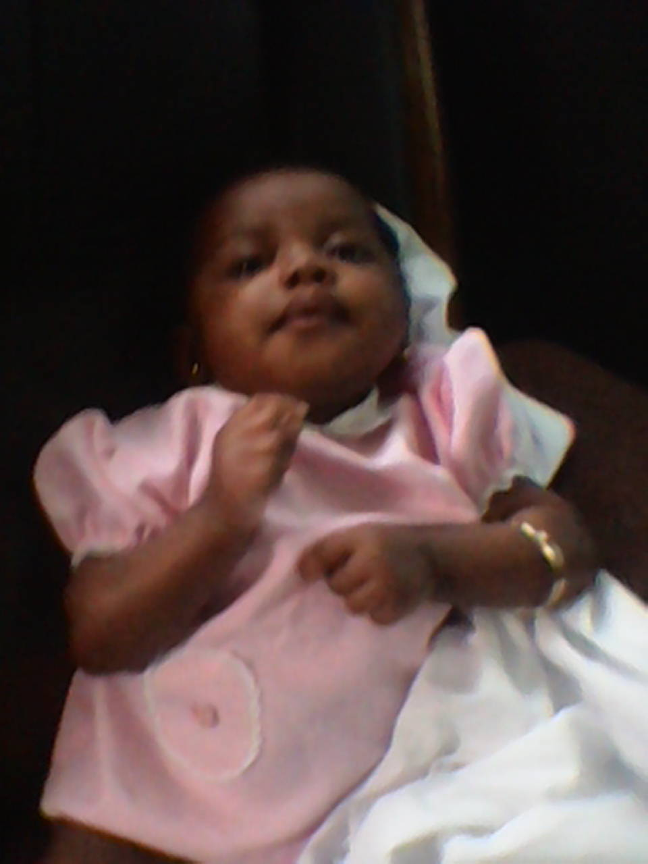

**5.5 ANTE-NATAL SERVICES**

Ante-Natal and Post Natal Clinic is weekly held at the Maternity Department. It is the midwife’s and the community Health Nurses manage this department. Vaccines are given to the mothers during Ante-natal Clinic (ANC). See below pictures, table and graph for interpretation

|  |  |  |  |  |
| --- | --- | --- | --- | --- |
| **ANTE-NATAL AND POST NATAL REPORT FOR THE YEAR 2015** | | | | |
| **YEARS** |  | **2015** |  | **2014** |
| Registrants |  | 172 |  | 166 |
| Attendance |  | 801 |  | 852 |
| Total Cases |  | 973 |  | 1,018 |
| PNC Attendance |  | 183 |  | 178 |
| Mothers Immunized |  | 62 |  | 153 |

One of the Ante-Natal Clinic held at the Health Centre during the year 2015

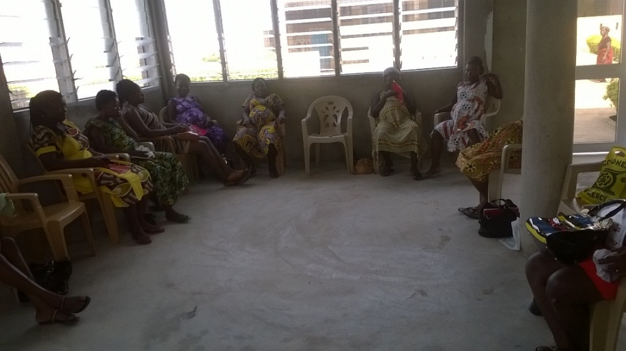

**5.6 CHILD WELFARE SERVICE**

Child welfare Clinic is held once a month at the clinic and four times in a month as part of Health Centre outreach program at Anum Amanfro and Anum Ofoase. Vaccines are given at Child Welfare Clinic (CWC) to the children. See below for some pictures, table and graph for interpretation on CWC Program.

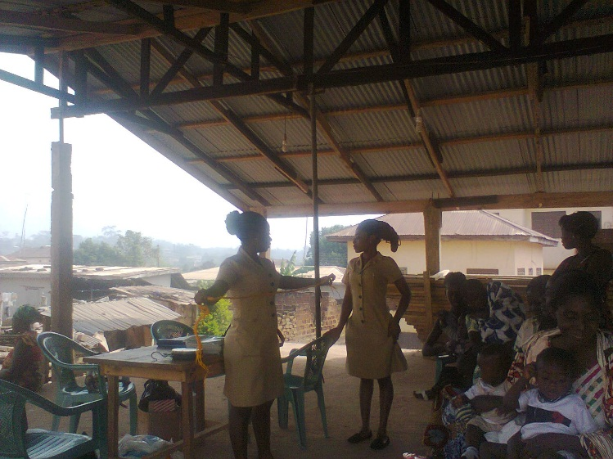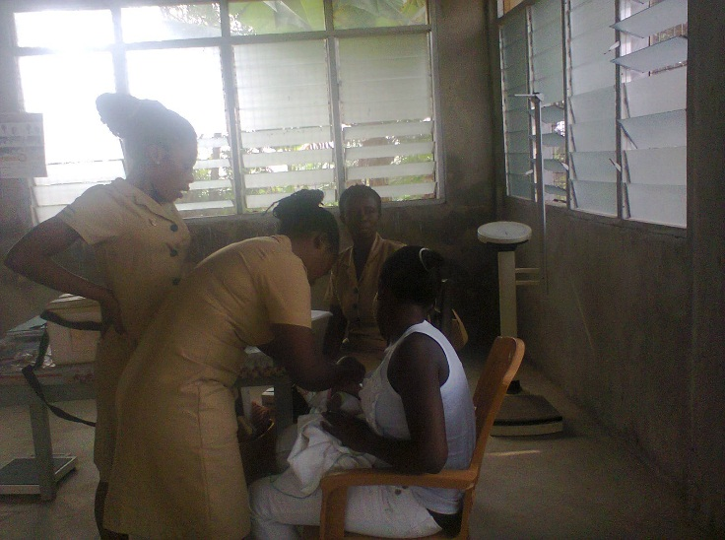The nurses administering vaccine to the babies. The nurses at outreach clinic.

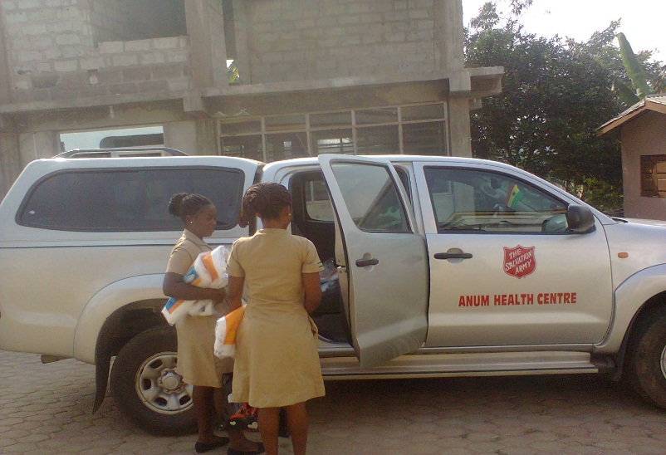The Ambulance is used for outreach programme

|  |  |
| --- | --- |
| **CWC 2015 WEIGHING ATTENDANCE (CLINIC)** | |
| **NEW** | 34 |
| **OLD** | 334 |

|  |  |
| --- | --- |
| **CWC 2015 WEIGHING ATTENDANCE (OUTREACH)** | |
| **NEW** | 94 |
| **OLD** | 1,766 |

**CLINIC AND OUTREACH IMMUNIZATION COVERAGE FOR THE YEAR 2015**

|  |  |
| --- | --- |
| **BCG** | 212 |
| **Y/F** | 122 |
| **MEASLES 1** | 122 |
| **MEASLES 2** | 82 |
| **POLIO 1** | 139 |
| **POLIO 2** | 128 |
| **POLIO 3** | 109 |
| **PENTA I** | 139 |
| **PENTA 2** | 122 |
| **PENTA 3** | 109 |
| **Rotavirus- 1** | 139 |
| **Rotavirus- 2** | 128 |
| **PCV - 1** | 139 |
| **PCV - 2** | 128 |
| **PCV - 3** | 109 |

|  |  |  |
| --- | --- | --- |
| **MATERNAL TETANOL VACCINE** | | |
| TT1 | 63 |  | |
| **TT2** | 62 |  | |
| TT 3 | 46 |  | |
| TT 4 | 21 |  | |

**VITAMIN A COVERAGE FOR THE YER 2015**

|  |  |
| --- | --- |
| **6-11 Month.** | 99 |
| **12-59 Month.** | 241 |
| **Maternal** | 150 |

**5.7 OUTREACH CLINIC**

Under the previous review years Anum Health Centre used to have six (6) outreach points around its catchment area but the Ghana Health Service has taking over five (5) of the Centre’s with their so call chip Compound. We have only Asikuma as outreach point and the health Centre have created two (2) Centre’s in Anum community as an outreach Child Welfare Centre (CWC).

Currently one Community Health Nurse is staying at Asikuma permanently therefore the Centre is conducted OPD services daily under year review at Asikuma. The clinic is open for 24 hours.

However, National Health Insurance Authority (NHIA) is requesting for the Centre to be accredited under NHIA scheme,

**Outreach attendance for the year under review**

|  |  |
| --- | --- |
| NEW REGISTRANTS | **827** |
| OLD | **1,170** |
| **TOTAL ATTENDANCE** | **1,997** |

**5.8 Referral System**

Patients whom we are not equipped to care for are referred to various hospitals, depending on the availability of services and relatives preference. Peki Government Hospital at Peki, VRA Hospital at Akosombo and Volta Reginal Hospital in Ho were usually used to refer cases.

VRA Hospital at Akosombo was normally used to refer the cases but currently, the repairs of the bridge at Atimpoku delay and prolong the time to reach Akosombo we therefore refer most of our cases to Peki Government Hospital at Peki and Volta Regional Hospital in Ho.

Referring patients to hospital often brings additional problems. Frequently, relatives are not prepared and delay in the search for money. Ambulances fees often go unpaid. Asking patients or relatives to make their own way to hospital is a risk as some will go untreated and die later as a result. At times patients are retained at the clinic when it has become obvious that the relatives will not go to hospital. The main reason for refusing hospital referral is lack of funds despite the implementation of the National Health Insurance (NHIS).

|  |  |
| --- | --- |
| CLIENT REFERED TO HOSPITAL DURING THE YEAR 2015 | |
| OPD CASES | 56 |
| LABOUR CASE | 21 |
| ANC CASES | 1 |

**5.9 Laboratory**

The lab department is being managing by a Laboratory Assistant and internally trained personnel to assist at the Lab. The following investigations are being done at clinic. The attendance at this department decrease from 5,549 to 5,055 which represent 9.8% for the year under review. See below for pictures, Tables and Graph for more interpretation.

The department conduct the following investigation.

1. BF
2. HB
3. Widal
4. Sick ling Cells
5. VDRL
6. Fasting Blood Sugar
7. Stool Routine
8. Urine Routine
9. Skin Snip
10. Pregnancy Test
11. HIV Test
12. White Blood Cells
13. WBC

Lab. Assist. Recoding and Conducting test for patient

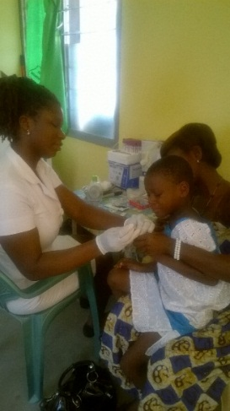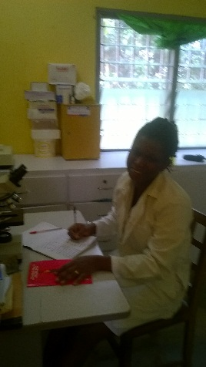

LABORATORY ATTENDANCE FOR THE YEAR 2015

|  |  |  |
| --- | --- | --- |
| **YEAR** | **2015** | **2014** |
| **TOTAL ATTENDANCE** | 5,055 | 5,549 |
| INSURED | 4,492 | 4,716 |
| NON INSURED | 563 | 833 |

**LAB. TOP SIX (6) INVESTIGATIONS CONDUCTED FOR THE YEAR 2015**

|  |  |  |
| --- | --- | --- |
| **YEAR** | **2015** | **2014** |
| BF | 4,648 | 4,226 |
| WIDAL | 1,489 | 2,758 |
| HB | 667 | 332 |
| URINE R.E | 265 | 113 |
| VDRL | 150 | 89 |
| SICKLING | 131 | 90 |
| OTHERS | 787 | 787 |
| TATOL | 8,165 | 8,234 |

**(6) HUMAN RESOURCES**

During the year under review the facility work with the under listed employee to achieve it aim and objectives.

Total number of employee required was Seventy – Eight (78) and total number at post was Thirty–One (31) which create a gab in the employee. The under list is the distribution of the employee.

|  |  |  |  |  |  |  |
| --- | --- | --- | --- | --- | --- | --- |
| **S/N** | **GRADE** | **NO. REQUIRED** | **NO. AT POST** | **GAP** | **NO. MECHANIZED** | **NO. NON MECHANIZED** |
| 1 | Health Service Administrator | 1 | 1 | 0 | 0 | 1 |
| 2 | Accountant | 1 | 1 | 0 | 1 | 0 |
| 3 | Medical Officer | 1 | 0 | 1 | 0 | 0 |
| 4 | Physician Asst | 1 | 0 | 1 | 0 | 0 |
| 5 | Medical Assistant | 3 | 1 | 2 | 1 | 0 |
| 6 | Mid. Officer | 2 | 2 | 0 | 2 | 0 |
| 7 | Staff Midwife | 2 | 0 | 2 | 0 | 0 |
| 8 | SRN | 9 | 1 | 5 | 1 | 0 |
| 9 | Prin, CHN | 1 | 1 | 0 | 1 | 0 |
| 10 | CHN | 17 | 3 | 14 | 3 | 0 |
| 11 | Prin. Health Assit. | 8 | 8 | 0 | 8 | 0 |
| 12 | Snr. Health Assit. | 2 | 2 | 0 | 2 | 0 |
| 13 | Enrolled nurse | 6 | 3 | 3 | 4 | 0 |
| 14 | Lab Technician | 1 | 0 | 1 | 0 | 0 |
| 15 | Lab Assistant | 2 | 1 | 1 | 0 | 1 |
| 16 | Accounts Officer | 2 | 0 | 2 | 0 | 0 |
| 17 | Biostatistics Assist. | 5 | 1 | 4 | 4 | 0 |
| 18 | Security guard | 3 | 2 | 1 | 1 | 1 |
| 20 | Labourer | 2 | 2 | 0 | 1 | 1 |
| 21 | Dispensing Assistant | 2 | 1 | 1 | 0 | 1 |
| 22 | Orderly | 1 | 1 | 0 | 0 | 1 |
| 23 | Driver | 1 | 0 | 1 | 0 | 0 |
| 24 | Secretary | 1 | 0 | 1 | 0 | 0 |
| 25 | Storekeeper | 1 | 0 | 1 | 0 | 0 |
| 26 | T.O Pharmacy | 3 | 0 | 3 | 0 | 0 |

Under the year review One (1) employee retired from the service in January 2015 and one (1) contract also ended in August 2015. The table below depict their Information.

|  |  |  |
| --- | --- | --- |
| **NAME OF STAFF** | **POSITION** | **DATE ENDED SERVICE** |
| Mr. Seth Obiri | Driver | (15th January 2015) |
| Mr. Robert Kodu Donkor | Medical Assistant | (31ST August 2015) |

Mr. Robert Kodua Donkor (MA) receiving his service Mr. Seth Obiri (Driver) receiving his Service

benefit from the Salvation Army Clinic – Anum benefit from the Salvation Army Clinic - Anum

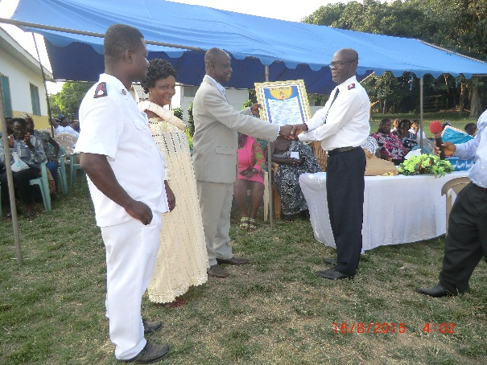 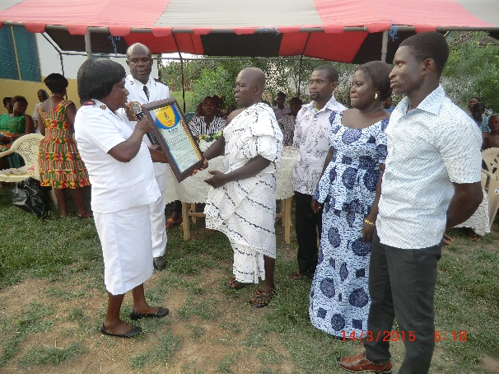

Some of Current employee of the facility

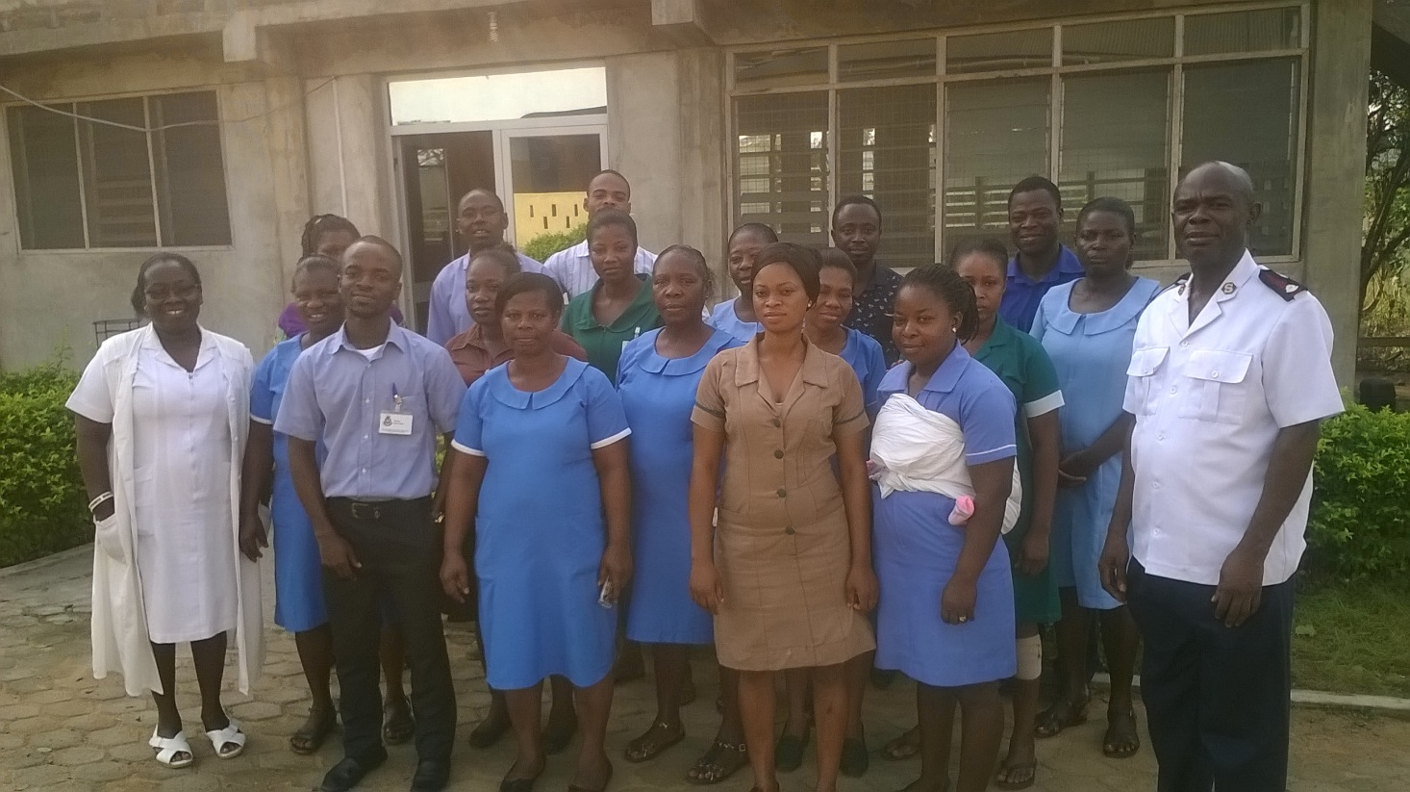

**(7) HEALTH FINANCING**

**7.1 Funding of the facility building project are as follows:**

1. The maternity and Administration building is being funding by the clinic from its internal generated fund (IGF). During the year under review the Anum citizens living in London and individuals supported the project with building materials.
2. The second building which is the theater is being funding by the Anum community and

The clinic.

**7.2 Income and Expenditure**

The facility received total income of two hundred and forty- three thousand, seven hundred and seventy-two Ghana cedis, thirty seven Ghana Pesewas **(GHS 243,762.37).** The expenses made during the year under review amounted to two hundred forty three thousand, two hundred and ninety four Ghana Cedis, twenty four Ghana Pesewas (**GHS 243,294.24)**.

Since the income generated exceed the expenses incurred the income and expenditure account recorded surplus of Four hundred and sixty eight Ghana cedis, thirteen Ghana pesewas. (**GHS 468.13)** for the year 2015.

|  |  |  |  |  |  |  |
| --- | --- | --- | --- | --- | --- | --- |
| **THE SALVATION ARMY HEALTH CENTRE -ANUM** | | | | | | |
| INCOME AND EXPENDITURE STATEMENTS FOR THE FINANCIAL YEAR ENDED 2015 | | | | | | |
|  |  |  |  |  |  |  |
| EXPENDITURE | 2014 | 2015 |  | INCOME | 2014 | 2015 |
|  | GH₵ | GH₵ |  |  | GH₵ | GH₵ |
| **Administrative Cost** |  |  |  | General Income | |  |
| Tithe/Sp. Cont. | 16,322.48 | 9,465.60 |  | Clinic Fees | 82,466.00 | 86,854.00 |
| Assessment | 6,050.00 | 7,562.50 |  | Discharges | 2,182.00 | 3,614.00 |
| Self-denial/Red shield | 700.00 | 900.00 |  | Outreach | 150.00 | - |
| Staff Salary/Allowance | 24,859.18 | 25,202.31 |  | Lab Fees | 27,720.00 | 28,899.00 |
| Staff SSf | 1,067.07 | 1,714.95 |  | Scan | 3,090.00 | 3,520.00 |
| Tax | 66.60 | 236.73 |  | Sundry | 180.00 | - |
| Fuel /Travel | 9,619.92 | 6,747.02 |  | NHIS | 144,812.88 | 120,875.37 |
| T&T | 6,776.00 | 6,878.00 |  | EED | 1,000.00 | - |
| Vehicle Repairs. | 1,885.31 | 4,541.90 |  | THQ Grant | 912.00 | - |
| Stationery | 946.40 | 1,541.90 |  |  |  |  |
| Social Cloth | 2,000.00 | - |  |  | - | - |
| Equipment’s | 15,570.00 | 1,000.00 |  |  |  | - |
| Inst. Repairs | 5,259.00 | 6,992.00 |  |  |  | - |
| Qtrs Rep | 431.50 | 640.00 |  |  |  | - |
| Billeting | 6,098.00 | 4,370.00 |  |  |  | - |
| Drugs | 108,845.55 | 95,483.37 |  |  |  | - |
| Supplies | 20,000.00 | 18,066.00 |  |  |  |  |
| Donation | 1,480.00 | 3,290.00 |  |  |  |  |
| Sundry | 4,396.49 | 8,700.10 |  |  |  |  |
| Office Expenses | 7,264.25 | 7,725.70 |  |  |  |  |
| Water Bill | 1,470.00 | 1,900.00 |  |  |  |  |
| Light Bill | - | 100.00 |  |  |  |  |
| Public Relations | 914.00 | 1,490.00 |  |  |  |  |
| Gas | 896.50 | 1,056.20 |  |  |  |  |
| Building Project | 22,043.00 | 9,598.50 |  |  |  |  |
| Generator /Mower Fuel | 1,336.00 | 2,629.00 |  |  |  |  |
| Lawn Mower Expenses | 55.00 | - |  |  |  |  |
| Staff Sponsorship | 8,750.00 | 9,169.00 |  |  |  |  |
| Vehicle Ins. | 2,067.88 | 2,067.88 |  |  |  |  |
| Uniforms | 761.60 | - |  |  |  |  |
| EED | 1,000.00 | 1,000.00 |  |  |  |  |
| Chag Dues | 1,245.29 | 1,369.82 |  |  |  |  |
| Property Ins. | 318.42 | 318.42 |  |  |  |  |
| Motor Ins. | 30.16 | 30.16 |  |  |  |  |
| Accreditation Renewals |  | 400.00 |  |  |  | - |
| Bank Charges (GCB) | 808.49 | 1,107.18 |  |  |  |  |
| SURPLUS/ DEFICIT |  | **468.13** |  |  | **18,821.21** |  |
|  | 281,334.09 | 243,762.37 |  |  | 281,334.09 | 243,762.37 |
|  |  |  |  |  |  |  |
| **THE SALVATION ARMY HEALTH CENTRE -ANUM** | | | | | | |
| **BALANCE SHEET AS AT 31ST DECEMBER 2015** | | | | | | |
| **LIABILITIES** | **2014** | **2015** |  | **ASSETS** | **2014** | **2015** |
|  | GH₵ | GH₵ |  |  | GH₵ | GH₵ |
| **SA CAPITAL** |  |  |  | **BALANCE** |  |  |
| BALANCE B/FORWARD | 18,966.80 | 145.59 |  | CASH IN HAND | 28.59 | 262.69 |
| ADD: SURPLUS / DEFICIT | (18,821.21) | 468.13 |  | CASH AT BANK | 117.00 | 351.03 |
|  | **145.59** | **613.72** |  |  | **145.59** | **613.72** |

**7.3 Submission and payment of National Health Insurance Claims for the year 2015**

The under list Summaries indicate how the facility manage it claims with reference to Submission and payment of National Health Insurance (NHIS). The total amount submitted for the year 2015 was one hundred and twenty eight thousand, and thirty eighty Ghana Cedis and forty five Ghana Pesewas **(GHS 128,080.45**).

The total amount received was forty eight thousand, two hundred and sixty six Ghana Cedis and forty one Ghana pesewas**. (GHS 48,266.41).** The Centre received seventy two thousand six hundred and eight Ghana Cedis, ninety two pesewas (**GHS** **72,608.92**) as claims submitted in the year 2014.

The outstanding amounted to seventy seven thousand, nine hundred and fifty five Ghana Cedis, seven Ghana pesewas. **(GHS 77,955.11)**

The total deduction by **NHIS** was one thousand eight hundred and fifty eight Ghana Cedis and ninety three Ghana pesewas. **(GH₵1,858.93)**

**Submission of NHIS Claims for the year 2015**

|  |  |
| --- | --- |
| TYPE OF REVENUE | GH¢ |
| JANUARY 2015 REGULAR CLAIMS (1st - 15th) | 6,509.89 |
| JANUARY 2015 REGULAR CLAIMS (16tt - 31st) | 5,622.29 |
| JANUARY 2015 ANC CLAIMS (1st - 31st) | 2,307.03 |
| FEBRUARY 2015 REGULAR CLAIMS (1st - 15th) | 5,126.39 |
| FEBRUARY 2015 ANC CLAIMS (1st - 31st) | 2,022.21 |
| FEBRUARY 2015 REGULAR CLAIMS (16th - 28th) | 3,707.43 |
| MARCH 2015 REGULAR CLAIMS (1st - 15th) | 4,789.25 |
| MARCH 2015 REGULAR CLAIMS (16th - 31st) | 4,783.59 |
| MARCH 2015 ANC CLAIMS (1st - 31st) | 2,422.44 |
|  |  |
| APRIL 2015 REGULAR CLAIMS (1st - 15th) | 5,298.03 |
| APRIL 2015 REGULAR CLAIMS (16th - 30th) | 4,465.14 |
| APRIL 2015 ANC CLAIMS (1st - 30TH) | 2,236.22 |
| MAY 2015 REGULAR CLAIMS (1st - 15th) | 5,876.17 |
| MAY 2015 REGULAR CLAIMS (16th - 31ST) | 5,573.20 |
| MAY 2015 ANC CLAIMS (1st - 31ST) | 2,123.41 |
| JUNE 2015 REGULAR CLAIMS (1st - 15th) | 5,772.93 |
| JUNE 2015 REGULAR CLAIMS (16th - 30TH) | 5,347.23 |
| JUNE 2015 ANC CLAIMS (1st - 30TH) | 2,088.51 |
| JULY 2015 REGULAR CLAIMS (1st - 15th) | 7,235.55 |
| JULY 2015 REGULAR CLAIMS (16TH - 31TH | 7,297.11 |
| JULY 2015 ANC CLAIMS (1st - 30TH) | 1,657.50 |
| AUGUST 2015 REGULAR CLAIMS (1st - 15th) | 5,643.43 |
| AUGUST 2015 REGULAR CLAIMS (16TH - 31ST) | 5,841.84 |
| AUGUST 2015 ANC CLAIMS (1st - 31ST) | 1,628.45 |
| SEPT 2015 REGULAR CLAIMS (1st - 30th) | 9,291.49 |
| SEPT 2015 ANC CLAIMS (1st - 30TH) | 1,944.06 |
|  |  |
| OCT 2015 REGULAR CLAIMS (1st - 31ST) | 9,525.41 |
| OCT 2015 ANC CLAIMS (1st - 31ST) | 1,944.25 |
| TOTAL | 128,080.45 |

**(8) HEALTH INFORMATION**

This is one of the measures or procedure used by the facility to prevent sickness within it operational or catchment area. When there is an outbreak of disease or national health issues the facility the following method to inform the community

Community durbar

1. Health talk in School
2. Health talk in Churches
3. Health talk at OPD
4. Staff devotion
5. During Ante-Natal Clinic
6. Child Welfare Clinic

See below for some pictures concerning the above subject.

**The Medical Assistant giving health talk on Malaria at Assembles of God Church Anum**

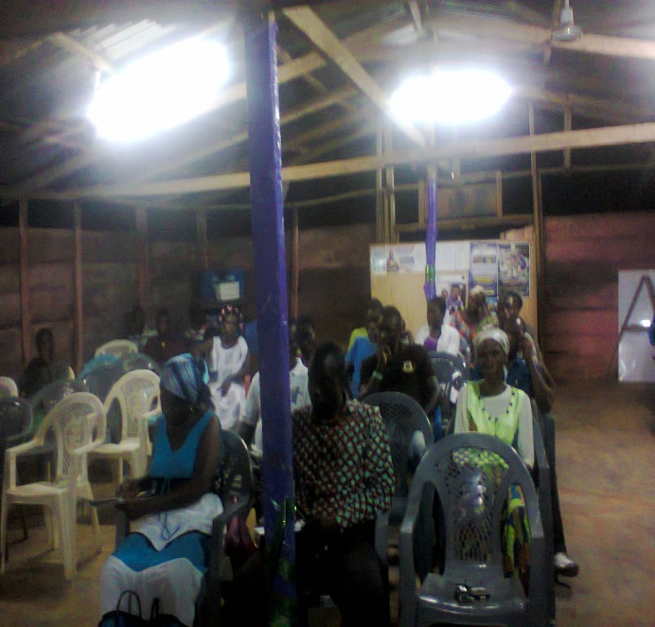 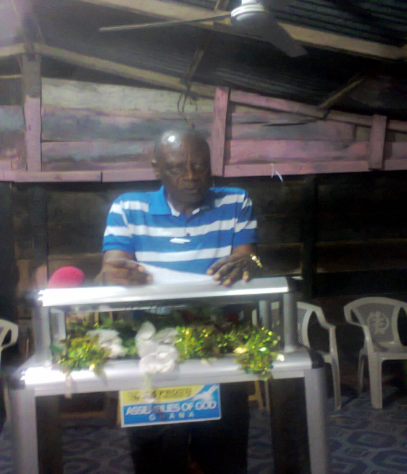

**The Community Health Nurse giving health talk on Malaria at OPD**

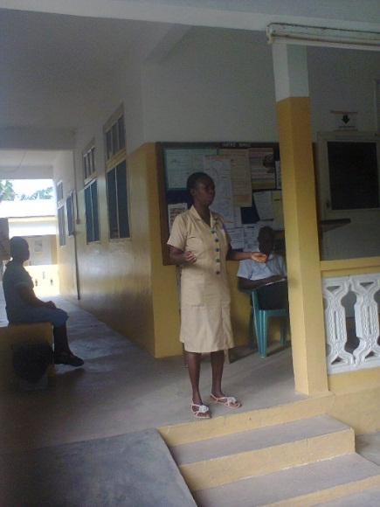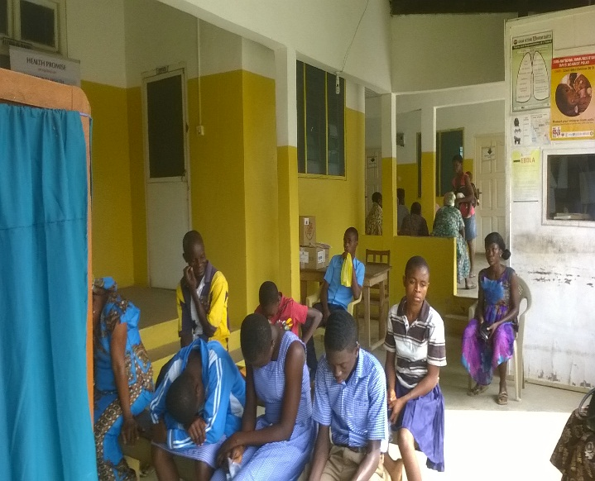

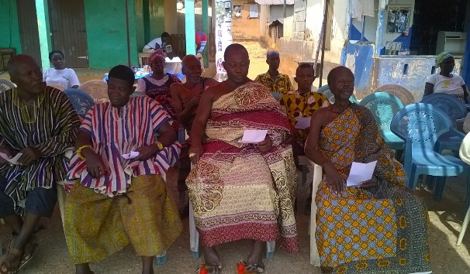**The Administrator giving health talk during community durbar at Anum**

**CHN, Midwife and Medical Assist giving Health talk during community durbar during the year 2015**

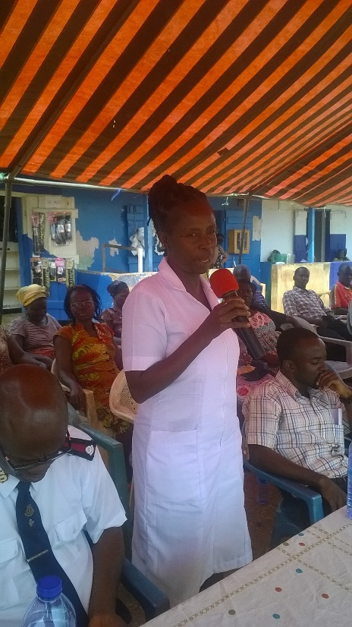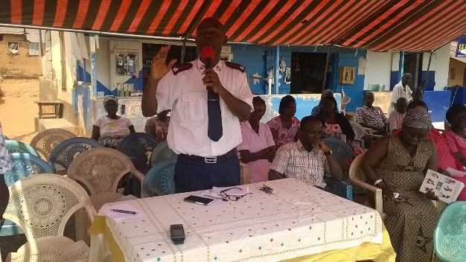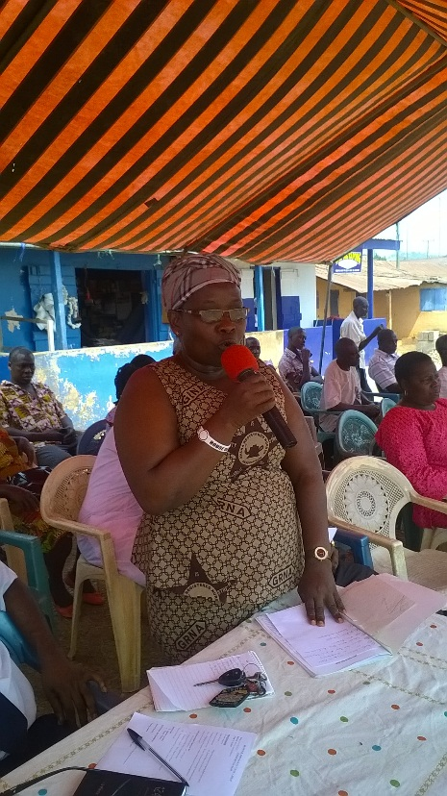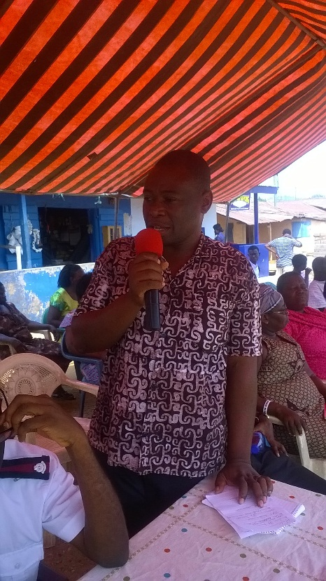

**Community durbar during the year 2015**

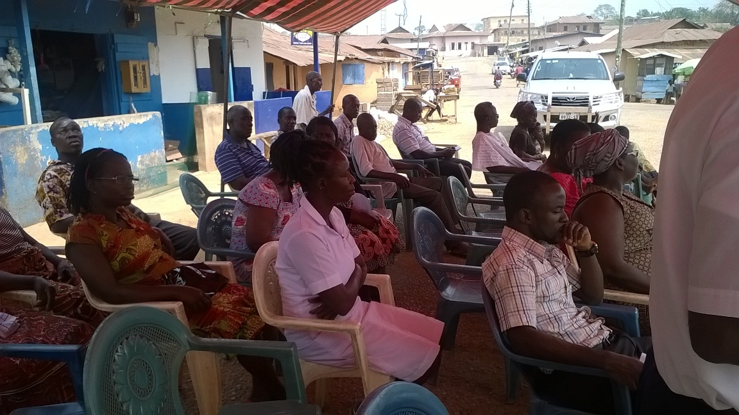

**(9) HEALTH TECHNOLOGY**

In reference to Health technology the facility used the application of organized knowledge and skills in the form of devices, medicines, vaccines, procedures and systems developed to solve health problems and improve quality of live.

**9.1 Knowledge and skills**

The facility send and sponsored staff for series of workshops and training to gain new knowledge and more current information relating to quality health delivery. Most of the staff awarded certificate for their training and some did not receive any certificate. See below pictures.

The Administrator presenting Certificate to Laboratory Assistant from HIV/AIDS workshop attended

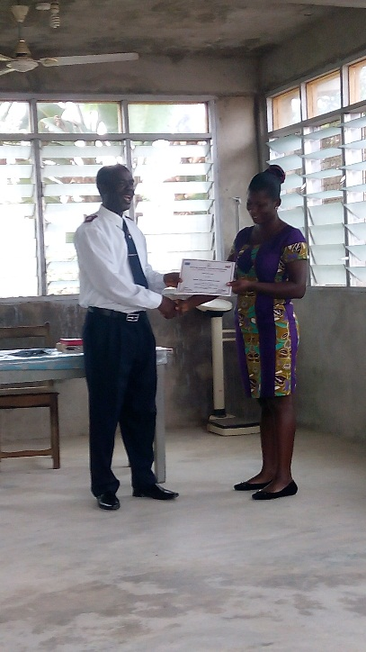

**9.2 Devices**

The facility also used equipment’s, devices, medicine and etc to solving health problems and improve quality of lives to its client during the reporting year.

**9.2.1 At Out Patient Department (OPD**) The facility check all patient vital signs including blood pleasure, temperature etc before going to consulting room to see the Medical Assistant. See below for pictures of the devices used.

A device used at OPD to check blood pressure

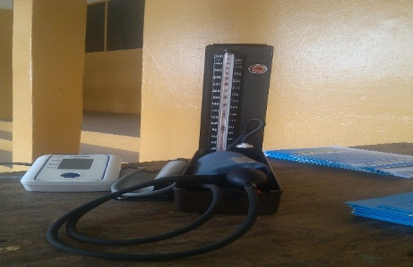

**9.2.2 Consulting room**

In consulting room the medical Assistant ask the patient to go for laboratory investigations after taking the history from the patient before he can properly diagnoseand treat.

**Medical Assistant in consulting attending to patient**

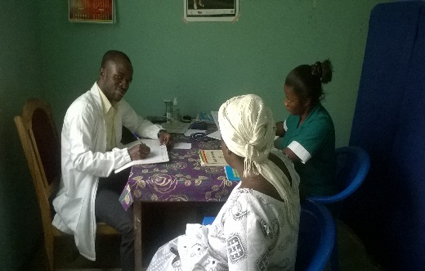

**9.2.3 In laboratory department**

The laboratory technician do investigations base on the medical assistant request on patient folder. Verities of equipment and devices are used to do the lab investigations. Some of them are shown below.

Oven for sterilization of other devices Spectrophotometer for HB

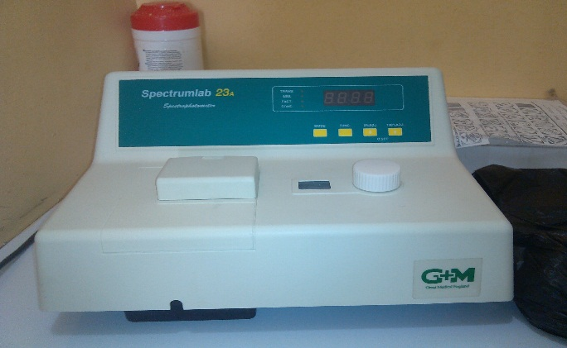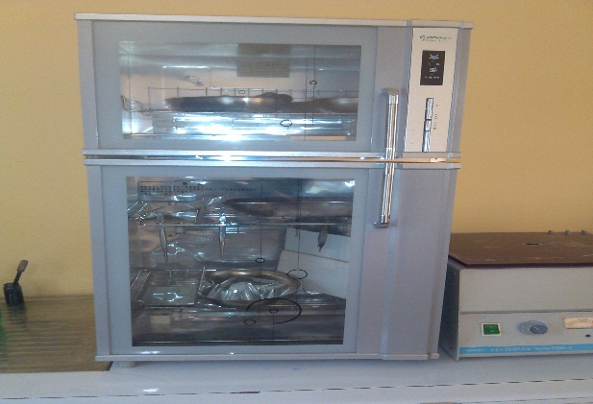

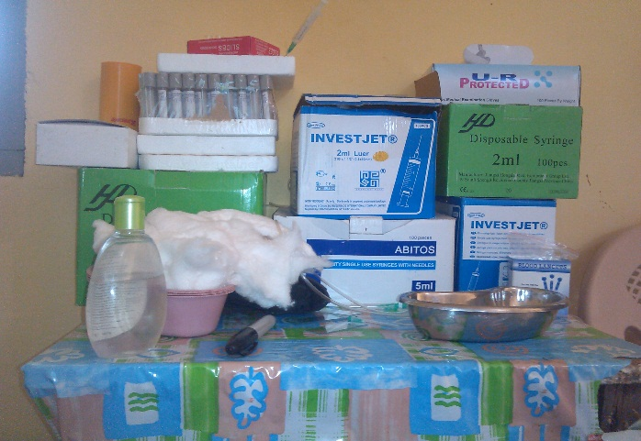Microscope for viewing microorganism other devices and solution used in lab dept.

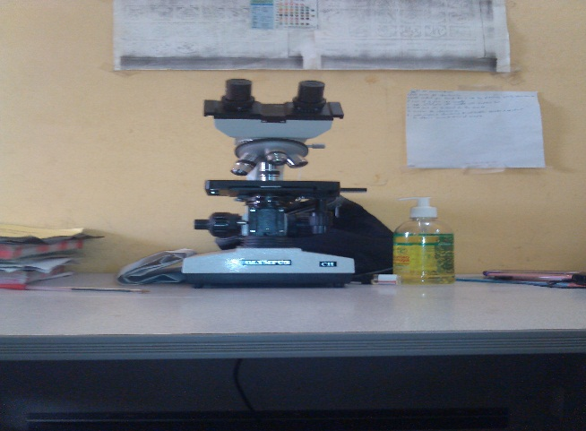  
**9.2.4 Maternity Department**

Different types of equipment and devices were used by the midwife in this department for delivery, ANC, and family planning to achieve safe delivery and solving health problems and improve quality of live for the year. Some of them are shown below.

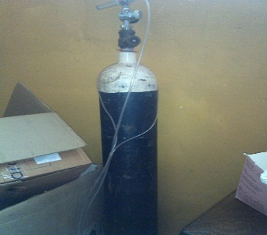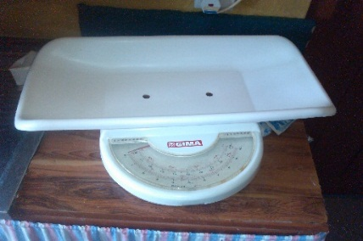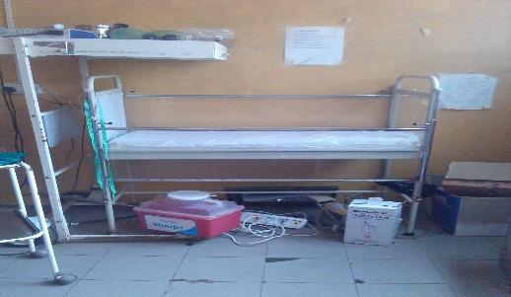 Delivery babies cut Babies weighing scale Cylinder for oxygen

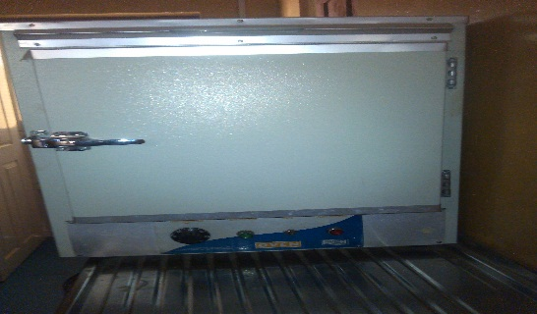Oven for sterilization of other devices Delivery bed

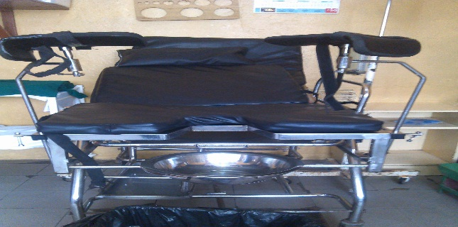

**(10) COMMUNITY PARTICIPATION AND OWNERSHIP**

The collaboration and the communication System with the chiefs, elders and the other opinion leaders in Anum and its catchment area has improved as compare to previous years. The community members assisted the facility in the following ways;

1. The citizens of Anum who residing in London (U.K) donated building materials to continue the Maternity and Administration building.
2. Other citizens of Anum who residing in USA, Canada donated hospital Medical suppliers, Beds and Lab and other Equipment.
3. Individuals, Institutions and group of people living Anum, Accra, Koforidua etc also contributed some building materials to continue the Maternity and Administration building.
4. The Community and schools in Anum periodically organized for communal labour to work at the Clinic this help solved some of the environmental problems.

See pictures below for some of the donations from the Community members.

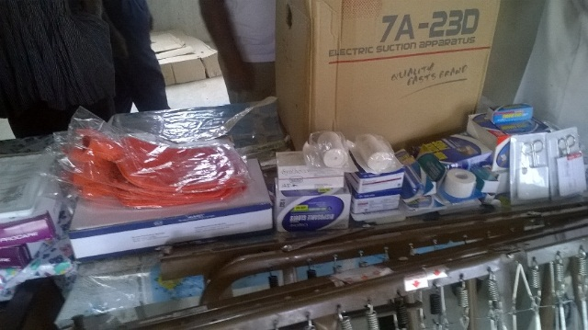**Donation of medical supliers from USA 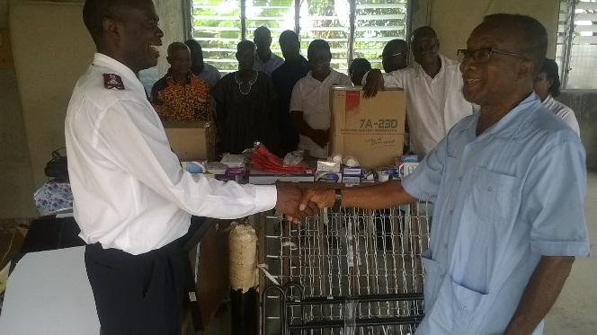 Donation of medical equipment and cement**

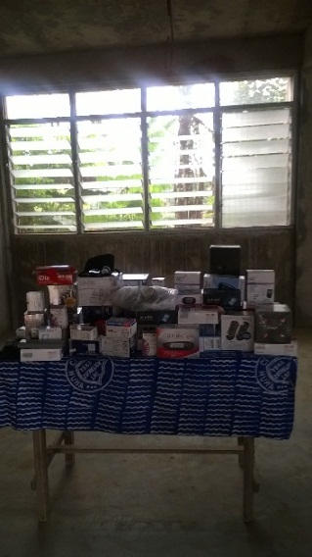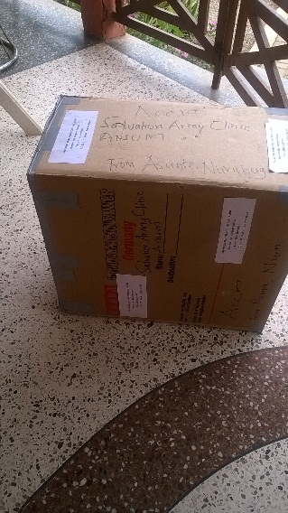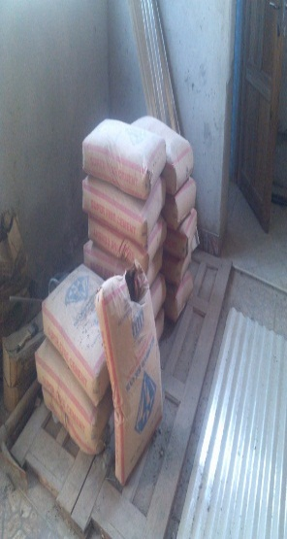

**After clean up exercise at the health facility by Anum Vocational Institute cadet**

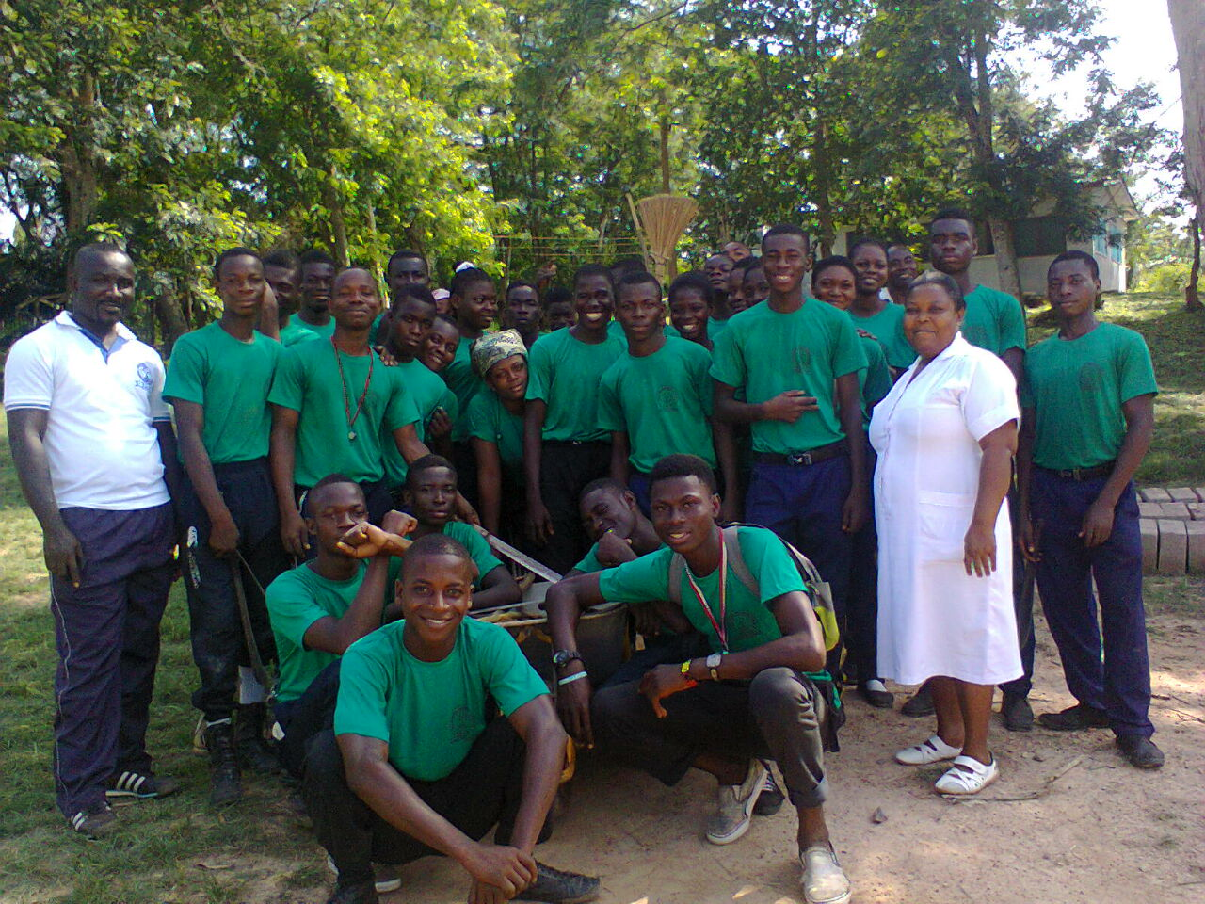

**Anum citizen leaving in U.K assist the facility to another road from the clinic to join the main raod which link Anum to Peki and it is better than the old road to the Clinic.**

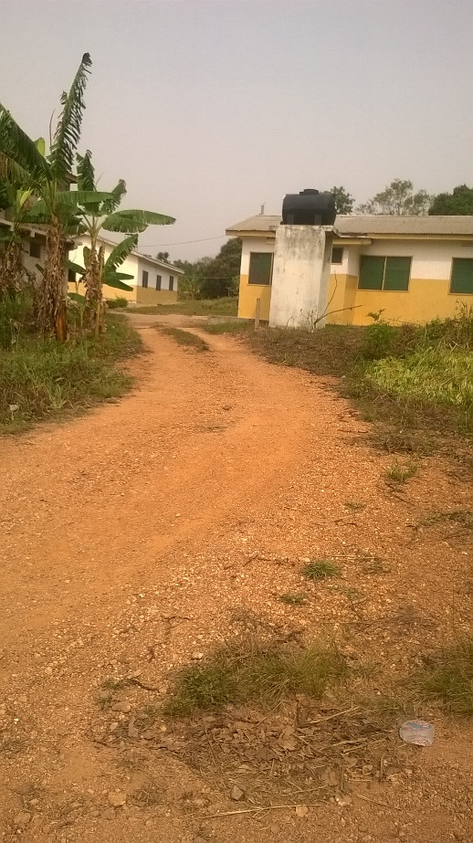

**(11) PARTNERSHIP DEVELOPMENT**

**1.** The facility have create good relationship between Blue Star Healthcare Network at Koforidua. The group assist the facility with staff training and logistics such as family planning devices, Malaria kits and etc.

Some of the training workshops organized for the members in the health facilities at Koforidua

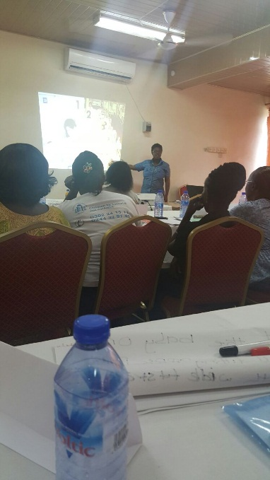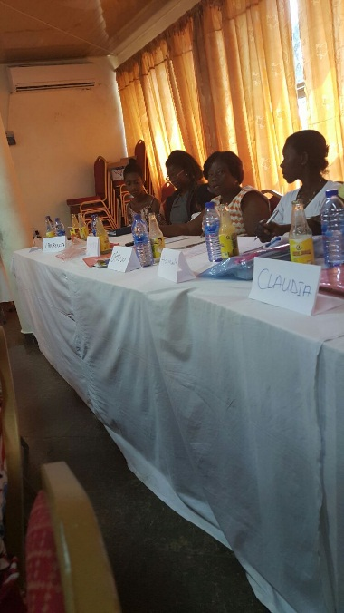  
This certificate awarded to the facility as a member of Blue Star Healthcare Network of marie Stopes International.

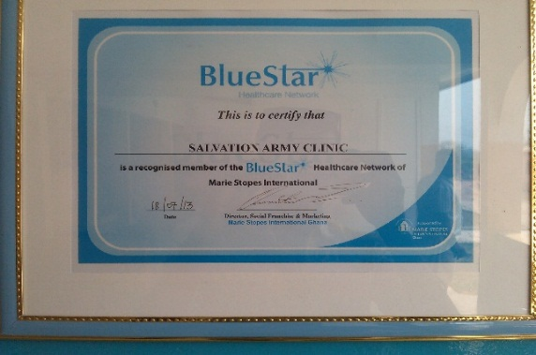

These pictures indicate some of the staff who attended workshops and training organized by the above mentioned partners. Those certificate were presented to the staff by the administrator.

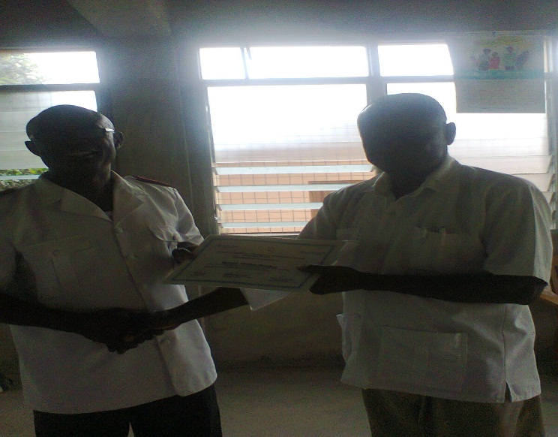Miss. Edith Abekah (CHN) Mr Robert Dornkor Kodua (MA)

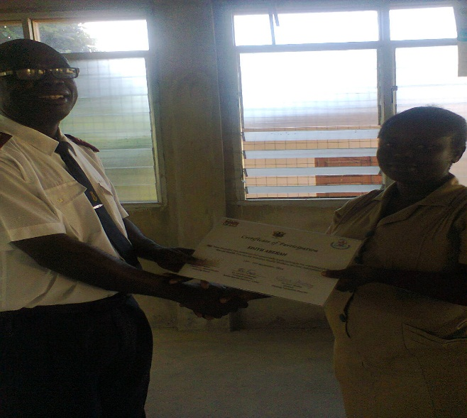

**2.** Collaboration between the facility and Asuogyaman District health administration has improve during the year 2015. The officers comes from the district for monitoring, collation of report for the sub district is done at Anum health Centre and the facility receives regular health information and invitation of the facility to various DHA meetings.

**(12) VISITORS DURING THE YEAR**

During the year various dignitaries, Institutions and personnel visited the health Centre some of them are as follows;

**(12.1) Overseas visitors**

1. A medical Doctor from Anum who is residing in United State of America by name Dr. Kwaku Bada pay a visit to the facility and donate some medical supplies to the facility.
2. Another Citizen from Anum who is residing in London visited the facility and presented medical supplies and water dispenser.

Washing machine Donated by Mr. Stephen Ofosu Ahiman

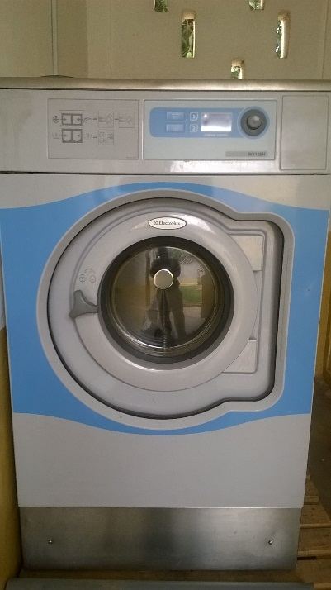 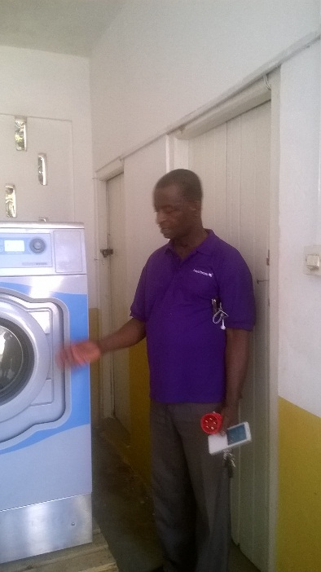

1. A representative of the Anum citizen who are residing in U.S.A also visited the facility and donated the hospital beds.

Hospital bed and other medical equipment donated

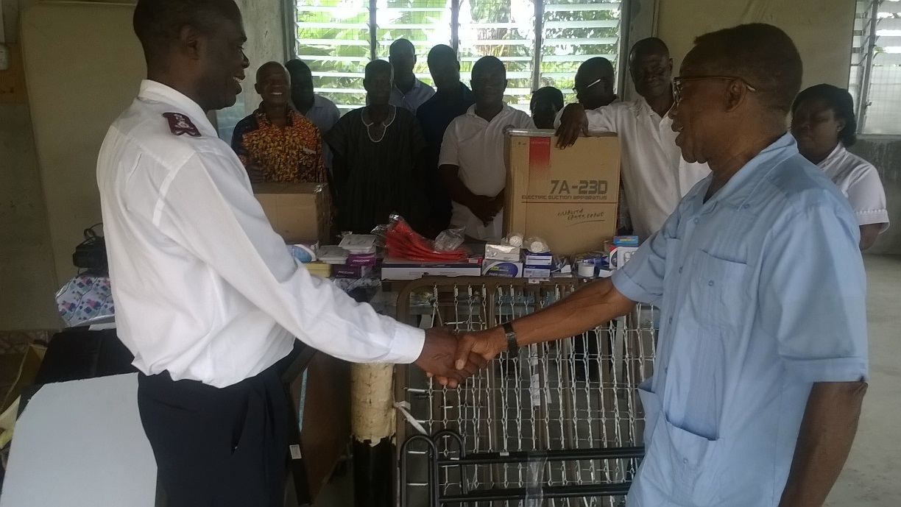

(12.2) Local Visitors

1. Director, Medical, Social and Community Services (DMSCS) of the Salvation Army Ghana Territory by name Heather Joy Craig (Major) made couple of visit to the facility during the year 2014. One of her visit meeting the staff pictures below

After Meeting of the staff Group Picture Meeting of the staff

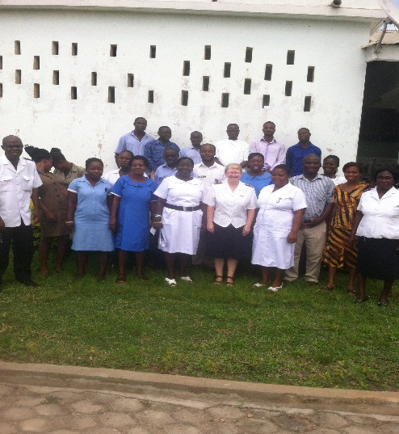 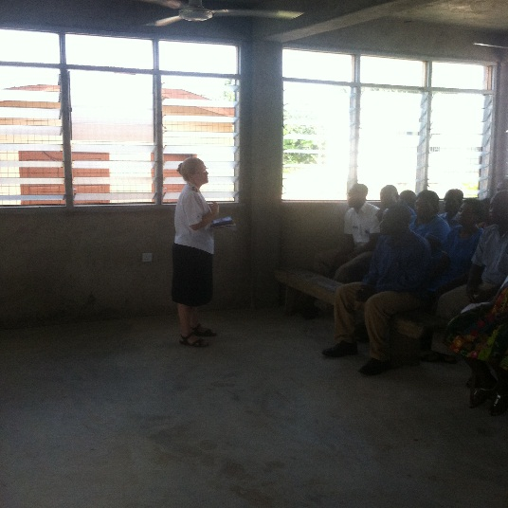

1. Personnel from National Health Insurance Visited the facility and also the used the facility to Renew and register subscribers. Below is a picture of one section of their visit.

**Registering and renewals of NHIS cards.**

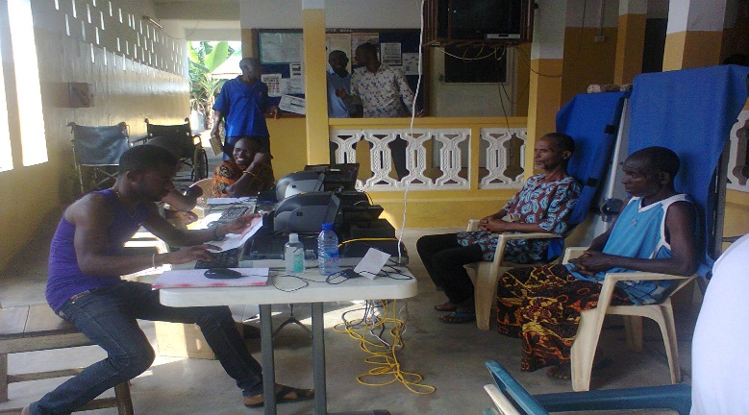

1. The District Chief Executive and the District Director of Asuogyaman District visited the facility to see the stage of the Community Theater Building.
2. The district Health officers visit the facility for monitoring and collection of monthly report from the sub district facilities.

**(13) DELIVERIES AND FUNERAL**

**(13.1) One staff bereaved during the year 2015.**

|  |  |  |
| --- | --- | --- |
| **NAME OF STAFF** | **POSITION** | **RELATIONSHIP WITH THE DECEASED / DATE** |
| Angelina Addo | Prin. CHN | Sister (23rd June 2015) |

**(13.2) No staff delivered during the year 2015.**

**(14) CONCLUSION**

In conclusion performance of the clinic has improve in terms of statistical data captured as compare to the previous year.

The delay in payment of NHIS claims created financial problems for the clinic. This made the clinic not to complete it building projects.

**(14.1) GOALS**

The Centre have classified this point under two (2) major heading and they are as follows:

**(14.1.1) Short term goals**

1. To complete the Maternity and Administration building at the end of 2015

2. One Midwife to be added to the staff nominal roll.

3. One Community Health and two auxiliary staff to be at Asikuma permanent for the clinic to be run 24hours daily

**(14.1.2) Long Term Goal**

1. To complete the Theater block within three (3) years
2. None mechanized staff to be mechanized into the government pay roll.
3. The road from the junction to the clinic to be renovated.
4. To renovate the two staff quarters**.**
5. Staff ban gallous to be constructed within the next Five (5) years

**(14.2) CHALLENGES**

1. Poor link road to the clinic.
2. The delayed of National Insurance payment since the majority of our clients are insured.
3. The community high expectation of the Health Centre to become hospital.
4. Lack of Staff quarters.
5. Medical Doctor is needed after the completion of the theater.

State of the assess road from the main road to the Health Centre

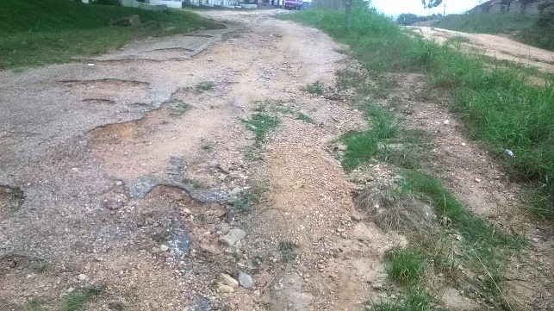

**(14.3) ACHIEVEMENTS / SUCCESS**

1. Approximately 97% and 65% of the maternity and administration building project respectively is completed. Even though we were determine to complete the project at end of the year 2010 but we couldn’t due to the inability of the National Insurance to pay us on time.
2. Finance, resource mobilization and management has improved in following areas:
3. Mechanization of staff (One newly qualify staff have been added unto the nominal roll).
4. Process used to collect and manage the IGF has improved.
5. Relationship between the clinic the Anum traditional council has improved.

**(14.4) WAY FORWARD**

**1. Outreach Centre**

The facility is looking forward to establish outreach clinic at Woadze by the year 2016. The Chief and his elders requested to Salvation Army to extend their health services to them and their surrounding communities.

Per their quest the facility made a follow up visit for feasibility study of the project and it indicated that the community have put up a building structure for a mobile clinic and have stated building on their permanent site for Clinic.

This project did not carried out because of National Health Insurance Policy Below are the current stage pictures of the buildings in the year 2015

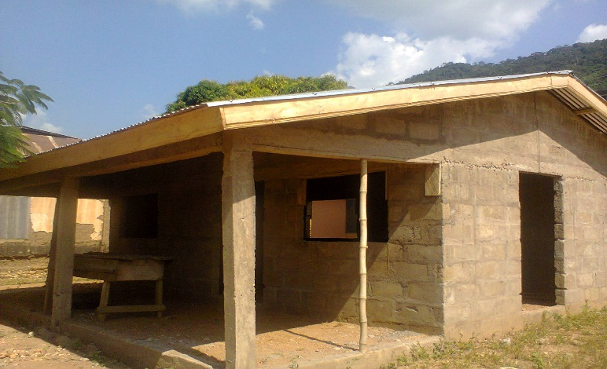Foundation level of the permanent Clinic. The stage of their mobile clinic building

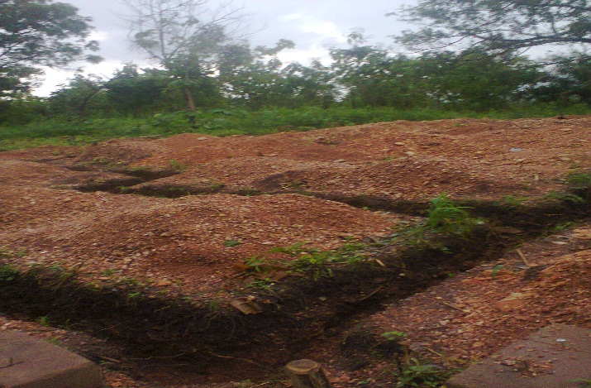

**(14.5) acknowledge**   
The Management, Expenditure Board of the Centre write to express their appreciation to many individuals and institutions who have supported the work of the Centre to achieve it aims and objective. Those individuals and institutions includes;

1. The Salvation Army International Headquarters.

2. The Salvation Army Ghana Territory

3. Major Heather Joy Craig (DMSCS)

4. The Christian Health Association. (CHAG)

5. Ministry of Health.

6. Ghana Medical Store

7. Ghana Health Service

8. Asuogyaman District Assembly

9. Asuogyaman District Mutual Health Insurance

10. Asuogyaman District Health Administration

11. The Chief and Elders of Anum

12. The Staff of Akosombo Hospital

13. The Staff of the Salvation Army Health Centre - Anum

And other individuals who contributed some gift in kind to support the clinic.

**(15) APPENDIX (I)**

**Patient's Charter**

There have been concerns about health service delivery in Ghana. Most of the concerns relate to the relationship between healthcare providers (Hospitals, Clinics, Healthcare center’s etc.) and their patients / clients. It has been noted that most patients / clients are either ignorant of their rights and responsibilities or do not insist on their rights or carry out the responsibilities expected of them.

This article seeks to highlight the rights and responsibilities of patients / clients with the view to encouraging mutually beneficial relationship between healthcare providers and their patients / clients. A patient’s rights are what he/she expects when he/she sees a doctor or go into a healthcare facility for treatment. On the other hand the patient’s responsibilities are what he/she is expected to do to assist the healthcare providers to make him/her feel better.

The Ghana Health Services (GHS) has come out with a Patient’s Charter which aims at ensuring that Healthcare Providers as well as Patients/Clients and their families understand their rights and responsibilities.

The Patient’s Charter addresses the under listed:

• The Right of the individual to an easily accessible, equitable and comprehensive healthcare of the highest quality within the resources of the country.

• Respect for the patient as an individual with a right of choice in the decision of his/her healthcare plans.

• The Right to protection from discrimination based on culture, ethnicity, language, religion, gender, age and type of illness or disability.

• The Responsibility of the patient/client for personal and communal health through preventive, promote and simple creative strategies.

**THE PATIENT’S RIGHTS**

1. The Patient has the right to quality basic healthcare irrespective of his/her geographical location.

2. The Patient has the right to know the identity and professional status of those who care for him/her. All staff of the healthcare provider are expected to wear name badges/tags.

3. The Patient is entitled to full information on his/her condition and management and possible risks. This should be explained in terms that he/she can understand and to have his/her questions answered concerning the diagnosis, prognosis and treatment.

* The Patient is entitled to know the alternative treatment(s) and other healthcare providers if these may contribute to improved outcome.
* The patient has the right to be informed and asked whether he/she wishes To participate in medical research being conducted by the healthcare provider.
* A Patient who declines to participate in or withdraw from a medical Research project is entitled to the most effective care available.
* The Patient has the right to privacy during consultation, examination and treatment. The healthcare provider, the doctors, nurses and other healthcare professionals will protect the patient’s privacy as much as possible.
* The Patient is entitled to confidentiality of information obtained about him/her and such information shall not be disclosed to a third party without his/her consent or that of the person entitled to act on his/her behalf, except where such information is required by law or is in the public interest.

4. The Patient is entitled to all relevant information regarding the policies and regulations of the health facilities he/she attends.

5. The Patient has a right to know about hospital procedures such as patient complaints and grievance processes, ethics committee etc. That can help him/her to resolve problems and questions about his/her hospital stay and care.

• Hospital charges, mode of payments and all forms of anticipated expenditure shall be explained to the patient prior to treatment. The Patient can request for summarized list of charges.

• The Patient is entitled to personal safety and reasonable security of property within the confines of the healthcare facility.

• The Patient has the right to a second medical opinion if he/she desires.

**THE PATIENT’S RESPONSIBILITIES**

The Patient is responsible for the following:

a. Providing complete and accurate information about his/her health, including present condition, past illnesses, hospitalizations and medications. This will assist in the Patient’s diagnosis, treatment, counselling and for rehabilitation purposes.

b. Asking questions when he/she does not understand information or instructions given regarding his/her diagnosis or treatment.

• Complying with prescribed treatment, reporting adverse effects and adhering to follow up requests.

• Informing his/her healthcare providers of any anticipated problems in allowing prescribed treatment or advice.

• Obtaining all relevant information, which have a bearing on his/her management and treatment including all financial implications.

• Recognizing the effect of lifestyle on his/her personal health. He/she therefore has to acquire knowledge on preventive, promote and simple curative practices and where necessary to seek early professional advice.

• Maintaining safe and hygienic environment in order to promote good health.

• Abiding by all hospital rules and regulations: o complying with the NO SMOKING policy.

o Complying with the visitor policies to ensure the rights and comfort of all patients.

• Treating the hospital staff, other patients and visitors with courtesy and respect.

• Leaving valuables at home and bringing only those items necessary during his/her stay in a hospital.

• Protecting the properties of the Health facility.

**CONCLUSION**

In all healthcare activities, the Patient’s dignity and interest are paramount. There is therefore the need for Patients to know their Rights and Responsibilities and to co-operate fully with healthcare providers to ensure effective health delivery.

**(16) APPENDIX (2)**

Budget for the 2014 to 2016

|  |  |  |  |  |  |  |  |
| --- | --- | --- | --- | --- | --- | --- | --- |
| **Social Fund** | | | | | | | |
| **Supporting Schedules Anum Clinic** | | | | | | | |
| **Proposed budget for the year ended 31st December 2014 - 2016** | | | | | | | |
|  |  |  |  |  |  |  |  |
|  |  |  |  |  | CEDIS |  |  |
| Sch |  | Actuals | Actuals | Approved | Proposed | Proposed | Proposed |
| No | Anum Clinic | 12 Months to | 6 Months to | Budget to | Budget | Budget | Budget |
|  |  | 31/12/2012 | 30/6/2013 | 31/12/2013 | 31/12/2014 | 31/12/2015 | 31/12/2016 |
|  | **EXPENDITURE** |  |  |  |  |  |  |
|  | Assessment to THQ | 4,200.00 | 3,500.00 | 5,040.00 | 6,440.00 | 7,840.00 | 9,240.00 |
|  | Tithe to THQ | 15,895.00 | 5,600.00 | 17,280.00 | 12,680.00 | 14,920.00 | 17,160.00 |
|  | Various | 5,640.25 | 2,543.60 | 523.60 | 7,122.08 | 8,139.52 | 9,156.96 |
|  | Employees’ Salaries | 19,014.84 | 10,196.43 | 23,711.00 | 28,550.00 | 32,628.58 | 36,707.15 |
|  | Employees SSF/Tax | 736.40 | 716.90 | 1,070.76 | 2,007.32 | 2,294.08 | 2,580.84 |
|  | Employees Sponsorship | 910.00 | 3,940.00 | 5,000.00 | 11,032.00 | 12,608.00 | 14,184.00 |
|  | Property Rents - Offices | 0 | 0 | 0 | - | 0 | 0 |
|  |  |  |  |  |  |  |  |
|  | Property Rents - Quarters | 0 | 0 | 0 | - | 0 | 0 |
|  |  |  |  |  |  |  |  |
|  | Folders/Cards | 6,300.00 | 4,400.00 | 4,600.00 | 12,320.00 | 14,080.00 | 15,840.00 |
|  | Office Expenses | 3,273.60 | 1,558.80 | 957.00 | 4,364.64 | 4,988.16 | 5,611.68 |
|  | Travelling & Transport | 1,484.00 | 818.00 | 1,205.60 | 2,290.40 | 2,617.60 | 2,944.80 |
|  | Vehicle Fuel | 5,761.00 | 3,072.82 | 6,498.80 | 8,603.90 | 9,833.02 | 11,062.15 |
|  | Washing |  |  |  | 144.00 | 151.20 | 158.40 |
|  | Provisions | 204.67 | 370.00 | 500.00 | 1,036.00 | 1,184.00 | 1,332.00 |
|  | Vehichle Repairs | 3,736.50 | 1,431.50 | 3,631.00 | 4,008.20 | 4,580.80 | 5,153.40 |
|  | Repairs & Replacement | 5,778.10 | 2,407.00 | 5,957.00 | 6,739.60 | 7,702.40 | 8,665.20 |
|  | ESB |  |  | 480.00 | 480.00 | 480.00 | 480.00 |
|  | Accountant Fee |  |  | 480.00 | 480.00 | 480.00 | 480.00 |
|  | Funeral |  |  | 480.00 | 480.00 | 480.00 | 480.00 |
|  | Vehicle Fund |  |  | 480.00 | 480.00 | 480.00 | 480.00 |
|  | Drugs / Medical | 89,142.71 | 54,981.89 | 103,490.60 | 153,949.29 | 175,942.05 | 197,934.80 |
|  | Rates |  |  | 3,128.40 | 3,128.40 | 3,128.40 | 3,128.40 |
|  | Staff Salaries (GOG) | 193,679.05 | 40,538.52 | 270,110.81 | 113,507.86 | 129,723.26 | 145,938.67 |
|  | Project | 31,855.60 | 13,880.80 | 21,000.00 | 40,254.33 | 45,806.65 | 51,358.97 |
|  | Gen. Set & Mower Fuel | 608.00 | 514.00 | 473.00 | 1,439.20 | 1,644.80 | 1,850.40 |
|  | World Service Appeal | 500.00 | 600.00 | 600.00 | 720.00 | 840 | 1,032 |
|  | Red Shield Appeal |  |  | 60.00 | 60.00 | 60.00 | 60.00 |
|  | Bank Charges | 406.92 | 234.27 | 264.00 | 655.96 | 749.66 | 843.37 |
|  | Auditors Expenses |  |  | 880.00 |  |  |  |
|  | Milk Powder Expenses |  |  | 400.00 | 400.00 | 400.00 | 400.00 |
|  | Building Insurance | 318.00 | 1,016.10 | 500.00 | 2,845.08 | 3,251.52 | 3,657.96 |
|  | CHAG Dues | 1,846.66 |  | 1,500.00 | 1,500.00 | 1,500.00 | 1,500.00 |
|  | EED Health Volunteers | 1,259.00 | 948.00 |  | 2,275.20 | 1,896 | 2,806 |
|  | Billeting | 690.50 | 1,045.50 | 886.60 | 2,927.40 | 3,345.60 | 3,763.80 |
|  | **Transfer to Reserves** | **488.32** | **20,718.58** | **2,545.84** | **36,479.19** | **30,525.51** | **22,375.15** |
|  |  |  |  |  |  |  |  |
|  |  | 393,729.12 | 175,032.71 | 483,734.01 | 469,400.04 | 524,300.82 | 578,366.19 |
|  |  |  |  |  |  |  |  |
| Sch |  | Actuals | Actuals | Approved | Proposed | Proposed | Proposed |
| No | Anum Clinic | 12 Months to | 6 Months to | Budget to | Budget | Budget | Budget |
|  |  | 31/12/2012 | 30/6/2013 | 31/12/2013 | 31/12/2014 | 31/12/2015 | 31/12/2016 |
|  | **INCOME** |  |  |  |  |  |  |
|  | Clinic/ Discharge | 5,414.00 | **3,267.00** | 6,319.20 | 9,147.60 | 10,454.40 | 11,761.20 |
|  | Sick Clinic | 17,542.00 | 20,142.69 | 19,975.20 | 56,399.53 | 64,456.61 | 72,513.68 |
|  | NHIS | 168,761.27 | 98,030.63 | 172,800.00 | 264,682.70 | 294,091.89 | 333,304.14 |
|  | Cards |  |  |  | - | - | - |
|  | THQ Grant |  | 541.00 | 5,000.00 | 1,406.60 | 1,568.90 | 1,623.00 |
|  | EED | 2,000.00 | 750.00 | 3,468.00 | 1,950.00 | 2,175.00 | 2,250.00 |
|  | Electricity Refund |  |  |  | - | - | - |
|  | Laboratory | 4,619.00 | 3,856.00 | 4,972.00 | 10,025.60 | 11,182.40 | 11,568.00 |
|  | Sundry Expenses | 1,713.80 | 7,506.87 | 388.80 | 19,517.85 | 21,769.91 | 22,520.60 |
|  | Red Shield Appeal |  |  | 100.00 | 110.00 | 120.00 | 130.00 |
|  | World Service Appeal |  | 400.00 | 600.00 | 760.00 | 920.00 | 1,080.00 |
|  | Staff Salaries (GOG) | 193,679 | 40,538.52 | 270,110.81 | 105,400.15 | 117,561.71 | 121,615.56 |
|  | Transfer from Reserves |  |  |  |  |  |  |
|  | ***Subtotal*** | 393,729.12 | 175,032.71 | 483,734.01 | 469,400.04 | 524,300.82 | 578,366.19 |
|  |  |  |  |  |  |  |  |
|  | Grant from Social Fund | 0 | 0 | 0 | 0 | - 0 | 0 |
|  |  |  |  |  |  |  |  |
|  |  | 393,729.12 | 175,032.71 | 483,734.01 | 469,400.04 | 524,300.82 | 578,366.19 |

On behave of the Director for Medical, Social and Community Service Major Heather Craig

Emmanuel Frimpong

Major

Administrator